

**FRIENDS OF VAUXHALL PARK** **NEWSLETTER No. 31**

**CULTURE 2020 PROPOSALS**

**A wide ranging consultation on the future of cultural services within Lambeth is in progress at the moment. The council faces unprecedented cuts to its core funding and this will, of course, have a profound impact on all of its spending. You are probably well aware of the cuts to the library service but you might not be aware that the fund for maintaining all of Lambeth’s parks and open spaces will be cut from £4.4m to £2.2m. It is difficult to see how anything apart from grass cutting and litter picking will be possible. Parks and open spaces will need to generate an income whether from events taking place or through other means to ensure that the even the current standard of maintenance can continue.**

**At the same time, Lambeth are encouraging groups such as the FOVP to take a more active role in the management of the Park. We have expressed interest to taking part in a Stage 2 model. The FOVP have agreed to pioneer a management board, which would have representatives from all sections of our community, to oversee how the budget for horticultural work is spent. This should ensure that the important jobs are done and we can target the work of the gardeners so that work is done at the right time for the plants and not just when the gardeners are able to visit. If you would like to take part, please let us know (07901 855887 or [friends@vauxhallpark.org.uk](mailto:friends@vauxhallpark.org.uk) ). We are working hard to make the best of a very bleak situation but we urge you to take part in the consultation: You can see the proposals in full by visiting** [www.lambeth.gov.uk/culture2020](http://www.lambeth.gov.uk/culture2020)  **or by picking up a copy from the Tate South Lambeth Library.**

**Ensuring safe, welcoming parks is vital to both physical and mental health and to well-being of all of our community. Some of you will remember the sorry state that Vauxhall Park was in 20 years ago and we would not want to return to those days. Please, please fill in the questionnaire in the consultation document or let our councillors (Jane Edbrooke, Jack Hopkins and Claire Holland) know how important is to you that Vauxhall Park, and the many other open spaces, are not allowed to become no-go areas. You can also email** [**culture2020@lambeth.gov.uk**](mailto:culture2020@lambeth.gov.uk)**. The consultation closes on 24 April.**

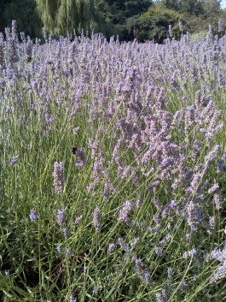**LAVENDER GARDEN IS OFFICIALLY A HIDDEN GEM OF LONDON!**

**Following an article in the Evening Standard we proposed the Vauxhall Motors Centenary Lavender Garden as a ‘Hidden Gem of London’ . Our secret is out - it has been selected to be on the final list which will be available on the Visit London website.**

**SUMMER FAIR**

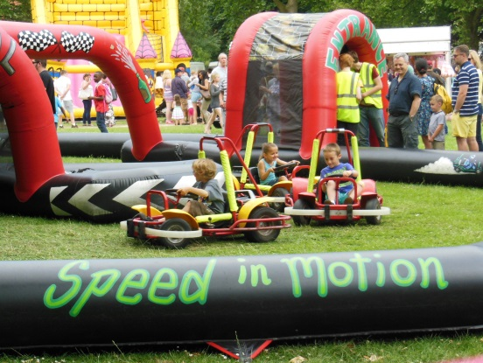**After the roaring success of last year’s fair, we are pleased to announce that this year’s fair will be held on Sunday 21 June from 2-5pm. We are delighted that Winkworth have agreed to sponsor the fair again. Come and be entertained by musicians, take part in or just watch Vauxhall’s talented and adorable dogs, eat delicious cakes and hot food, enjoy the Oval Montessori’s many childrens’ games, wear the kids out on the bouncy castles, go karts and new for this year a rodeo bull! We have stalls available for a very modest fee – please contact us (details as before) for further information. We always need helpers on the day to help the day go with a swing – we hope to hear from you!**

**A NEW PLAYGROUND FOR VAUXHALL PARK**

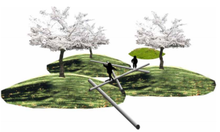**The FOVP have been working in conjunction with Lambeth Council and Kinnear Associates to design a new playground for the Park. We will be displaying our initial ideas at the Easter Egg Hunt on Saturday 28 March but the plans will be available for further consultation before anything is decided (please keep an eye on our website and information on Park display boards). We have a bold vision of a playground that will challenge, encourage and entertain. It will be a 21st Century playground but with a strong sense of its place within a historical park.**

**FUTURE DATES**

**SUMMER FAIR 21 JUNE 2-5PM**

**OPEN MEETING 26 SEPTEMBER**