FRIENDS OF VAUXHALL PARK NEWSLETTER No. 32

WE ARE A CHARITY!
Thanks to the expert help of a local resident, the Friends of Vauxhall Park have successfully applied to the Charities Commission to become a charity, Registration Number 1166894. As a result of this, we have adopted a new Constitution (which can be seen on the home page of our website www.vauxhallpark.org.uk) and the FOVP has become a Charitable Incorporated Organisation (CIO). Amongst other things, we now are able to claim Gift Aid on donations so any money given to the Friends will go 20% further. We will be actively seeking to raise funds for specific projects and hope you will support us. One of our first projects will be the replanting of the Vauxhall Motors Centenary lavender field which is now 13 years old and the plants are at the end of their life.

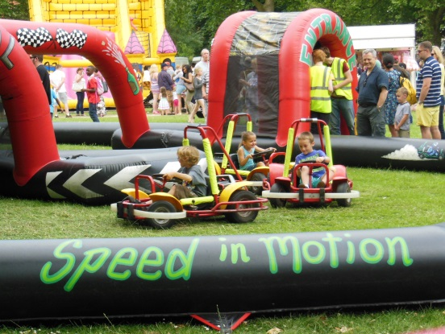
SUMMER FAIR 2016
On 26 June from 2pm until 5pm a Fair full of delights will once again take place in the park: We will have donkey rides (or, if you fancy something a little more challenging, a Rodeo Bull), motorised go karts, children’s games supplied by the Oval Montessori Nursery School, stalls, delicious hot food, a Pimms Bar, ice cream, bouncy castles, football training by Chelsea Football Club (and sponsored by Fire nightclub), dance displays and music through the day, Punch and Judy, face painting, a dog show, a magic show and our very own Vauxhall Lavender.
We are looking for helpers for the day. Please contact us on 07901 855887 or friends@vauxhallpark.org.uk if you could volunteer – a sense of humour and comfortable shoes are the only requirements!
We are very grateful to Winkworth Kennington for once again sponsoring our Summer Fair. They not only give us a substantial contribution to the cost of the fair but also pay for the wonderful banners on the park railings, the posters and the flyers that come through your letterboxes. Winkworth sponsor a number of other community events in the Vauxhall/Kennington area and they are true champions of our communities

Friends of Vauxhall Park Registered Charity 1166894
www.vauxhallpark.org.uk

MAINTENANCE
You may have noticed that Veolia operatives no longer work in the park: The Veolia maintenance contract was not renewed by Lambeth Council and the upkeep of their open spaces has been taken back in-house. The gardening staff will be known as Lambeth Landscapes. We are very grateful to Community Payback for continuing to provide working groups in the Park to help fill in gaps. These are very challenging times for everyone involved in Open Spaces: A 50% cut to the maintenance budget means that hard choices need to be made and standards of upkeep will not be what they were. We thank Theresa, our Parks Officer, for her hard work in difficult times.
INVESTMENT IN VAUXHALL PARK
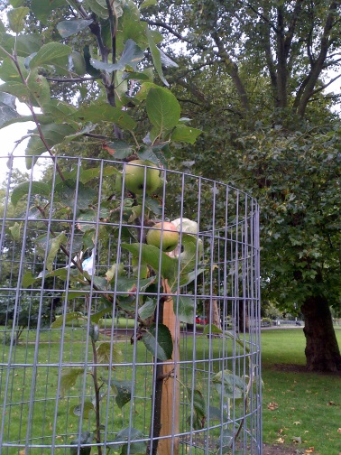
By taking an active role in the planning applications for the developments around the park, the FOVP has secured a substantial amount of money for investment in the facilities of the park (but, unfortunately due to the terms of the planning gain monies, not in the maintenance of the Park). Last year, Kinnear Landscape Associates were commissioned to produce a new Masterplan replacing one published in 2006 (we are now outside the time frame it considered). A number of proposals were suggested but Lambeth have now decided to award a new contract to work up costed investment in the Park. We are grateful that Lambeth have included the FOVP in this process and we look forward to seeing the delivery of real improvements in the Park, including the long promised new playground. We are delighted that Lambeth’s ambition is that Vauxhall Park should be ‘world class’ and an ‘exemplar park’ to help provide relief from the increasing urbanisation of the immediate area. We are very conscious that Vauxhall Park should retain its special character, as a place of reflection and calm complimenting neighbouring open spaces where other activities are provided.
THE ORCHARD
In December, our orchard was visited by a team of Master Orchardists from the Urban Orchard Project, who originally gave us our wonderful orchard. There was fierce debate amongst them about the finer points of pruning but they all agreed that our orchard was looking in good shape. The guards have been cut down to allow the trees to spread upwards and recently, some Russian Comfrey was planted beneath them to provide future nourishment for the trees.
Finally… it’s official: Research done by the University of Sussex and London School of Economics found that gardening is our favourite pastime and brings us the greatest happiness – hope to see you at our next gardening group (see website and notice boards for details)!

