FRIENDS OF VAUXHALL PARK NEWSLETTER No. 33

Parliamentary Inquiry into the State of Parks
We were very pleased that the threat to the state of UK Parks, due to cuts to maintenance budgets, has been recognised by a Parliamentary Inquiry; the funding of Parks is not obligatory for Local Authorities and many have had to make drastic cuts to their maintenance budget for Parks, including a 50% cut to the upkeep of Lambeth’s parks. The FOVP submitted evidence to the Inquiry and are pleased that the Inquiry have noted in their report, our suggestion that planning gain monies should be able to be spent on, for example, gardeners and not just on capital projects as at present. This more often than not leads to expensive ‘white elephants’ being imposed on the local community without the necessary funding to secure their long term use.
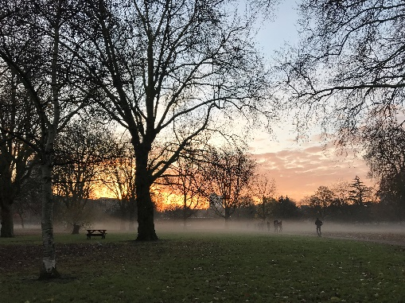
Vauxhall Park is at a crossroads and the FOVP needs the local community to join them in their efforts to keep this award winning park as a quality open space providing a vital lung and place of retreat from the increasing density of the surrounding area. We have addressed several local community groups recently with our message that we cannot take the park for granted. The FOVP have taken on many jobs including maintaining the entrance beds but we need the community to support us. Even if you just pass through on your way to work, we hope you will be able to do something to help:
- Do you have a skill or interest such as IT, social media, fund raising that you can share with us?
- If you’re not already a member, join us! Memberships start at just £2. The more people we can communicate with directly (and we promise we won’t do it too often) the better we can reflect the needs of the local community
- Join the committee to help us devise imaginative strategies to keep the park looking good
- Volunteer at our Easter Egg Hunt and at our regular gardening groups and the lavender harvest
- Volunteer at the Summer Fair – it’s a lot of fun!
- Could you or your company sponsor the fountain being turned on again, the planting around the model village etc.
- Contact us about ideas that you might have about how to celebrate our wonderful Park
We are delighted that Lambeth Council are currently recruiting a gardener to concentrate on Vauxhall’s parks and are grateful for all that they are able to do but we would like to do all that we can to support their work at this difficult time. Please don’t just pass by but help us to keep Vauxhall Park blooming. See our website (www.vauxhallpark.org.uk) for ways to contact us
AGM
Our AGM will be held at the Bolney Meadow Community Hall, 31 Bolney Street, London SW8 1EN on Saturday 18 March. Join us from 10am for refreshments before the main meeting at 10.30am. We will be re-electing committee members, hearing (hopefully) about the delivery of our Masterplan including a new playground, events for this year, and plans for supporting the work of Lambeth’s Park Department. Please come along to support your park. We would like to hear your views and answer questions

www.vauxhallpark.org.uk
Easter Egg Hunt
Now a firmly established part of the local community’s year, the Easter Egg Hunt will be on Saturday 1 April this year. Registration from 10.30am for the start of the hunt at 11am. The event is free for local children aged 1-10 years. Please could you volunteer to help at this event, it (and the chocolate) doesn’t last for long! Offers of help grateful received by either emailing us friends@vauxhallpark.org.uk or call 020 7735 4816. We are very grateful to Louise Norwood from the Oval Montessori Nursery School (situated in Vauxhall Park) for organising the hunt.
Vauxhall Motors Centenary Lavender Garden
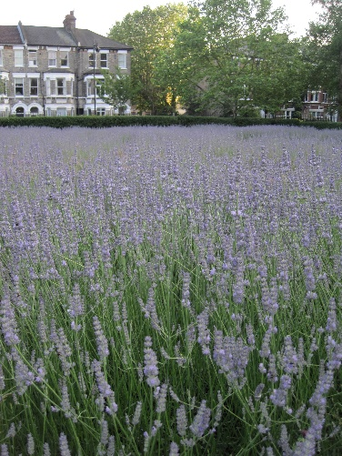
In 2004, Vauxhall Motors very generously sponsored the planting of the lavender garden to mark their Centenary (the company started life on the Wandsworth Road where Sainsbury’s now trades). The lavender was planted to replace the bowling green which had fallen into disuse and has provided the local community with an enormous amount of enjoyment over the years; from people seeking a tranquil place amongst the hurly burly of London life, to the fun that can be had at the annual harvest of the flowers so that they can be distilled into oil, all proceeds coming back into the park. However, the lavender is now coming to the end of its life. The FOVP will be seeking sponsorship to replant the lavender garden but with a slightly altered design, centred on the human sundial which was so generously given to us by a local resident. We have quotes from some local landscape contractors and are working towards grubbing out the existing plants after a final harvest in September. If you know of any companies that might be interested in supporting this project we would be very pleased to hear from you (friends@vauxhallpark.org.uk). Photo courtesy of Tommy Candler.
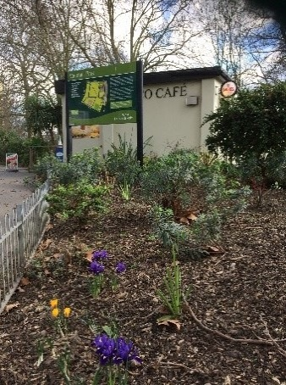
A gift of spring bulbs from the
Metropolitan Public Gardens Association

Last Autumn, we took delivery of 1,000 spring bulbs generously donated by Taylors Bulbs through the Metropolitan Public Gardens Associations. The Community Payback Team, who work in Vauxhall Park, planted them for us and we’re hoping that a good proportion of them escaped the attention of the local squirrels. As this newsletter is written the snowdrops and crocuses are already beginning to cheer us up with the promise of spring being just around the corner. Thank you Taylors Bulbs (www.taylors-bulbs.com)!

NEXT MEETING
AGM
SATURDAY 18 MARCH BOLNEY MEADOW COMMUNITY HALL
31 BOLNEY STREET, LONDON SW8 1EN
ALL WELCOME 10AM REFRESHMENTS 10.30AM START

www.vauxhallpark.org.uk Registered Charity 116894

