FRIENDS OF VAUXHALL PARK NEWSLETTER No. 34

Vauxhall Park Masterplan
We had hoped to report in this newsletter some concrete news about Vauxhall Park’s long awaited Masterplan. However, having delayed our AGM, an Open Meeting and the publication of this newsletter for as long as possible, we regret to say that are still unable to report any progress. The amount of money that will be invested in the Park, primarily from the Community Infrastructure Levy/Section 106 coming out of the new buildings springing up alongside the Park, has still not been ratified by the Council. Some interesting feedback came out of the Consultation that took place over the Summer to inform the plans but without a budget, no plans can be made! We understand that another firm of consultants will be commissioned to deliver the final plans and implement them. Watch this space….
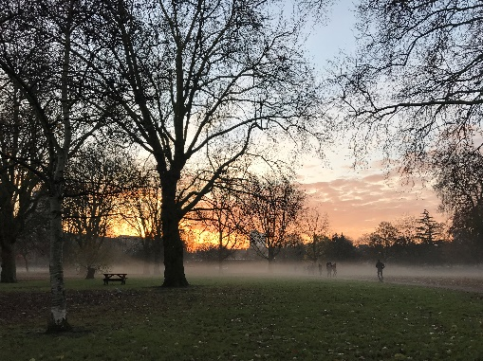
Vauxhall Park is at a crossroads and the FOVP needs the local community to join them in their efforts to keep this award winning park as a quality open space providing a vital lung and place of retreat from the increasing density of the surrounding area. The FOVP have taken on many jobs including maintaining the entrance beds but we need the community to support us. Even if you just pass through on your way to work, we hope you will be able to do something to help:

- Do you have a skill or interest such as IT, social media, fund raising that you can share with us?
- If you’re not already a member, join us! Memberships start at just £2. The more people we can communicate with directly (and we promise we won’t do it too often) the better we can reflect the needs of the local community
- Join the committee to help us devise imaginative strategies to keep the park looking good
- Volunteer at our Easter Egg Hunt and at our regular gardening groups and the lavender harvest
- Volunteer at the Summer Fair – it’s a lot of fun!
- Could you or your company sponsor the fountain being turned on again, the planting around the model village etc.
- Contact us about ideas that you might have about how to celebrate our wonderful Park
Please don’t just pass by but help us to keep Vauxhall Park blooming. See our website (www.vauxhallpark.org.uk) for ways to contact us
Sacred Trees
The Conservation Foundation's Trees for Sacred Spaces project, supported by the Church of England and Mayor of London offered free trees to Parishes in London. We are very grateful to St Anne’s Church (Miles Street) who gave us the chance to be the guardian to some of these trees. Two Wild Cherry trees and one crabapple were planted by FOVP to help improve our air quality, and support bees and other wildlife

www.vauxhallpark.org.uk

Green Flag
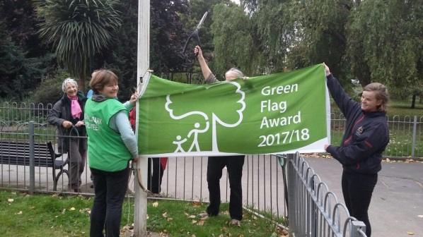
We were delighted to hear that Vauxhall Park has been awarded another Green Flag. The Green Flag scheme identifies the best open spaces around the country and the judging is done by a ‘mystery shopper’ (so no sneaky sprucing up at the last moment). We are very grateful to our amazing team of volunteer gardeners who look after the park on a weekly basis and who guide our gardening groups. We would also like to thank the Lambeth Parks Department and Community Payback who work in the park once a week tackling the jobs like leaf sweeping.
The next gardening group is on Saturday 2 December – meet at Parco Café at 9.30am.
No experience needed, tools and a hot drink to defrost afterwards will be provided. Please tell you neighbours and come to join in – it’s a great way to get involved in our wonderful community

2017 Events
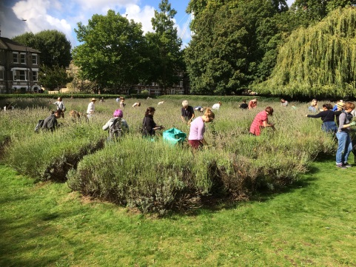
We have enjoyed a fantastic year of events: The shrieking of children finding Easter Eggs was soon followed by a spectacular Summer Fair. With Winkworth Kennington as our main sponsor and many local companies including CLS, Babcock Media, Mount Anvil and Barratt Homes supporting us, Christine Homer organised a specular day of fun for all in the Park. We are very grateful to her for proving to be such an imaginative and energetic organiser. The fair wouldn’t happen without the support of many other people including Louise Norwood and her team at the Oval Montessori Nursery School and Tessa King-Farlow and Anne Rogers who organised the Plant Stall.
The lavender harvest in September attracted a record number of helpers after both Time Out and Team London featured the event. Another team of volunteers came to Carshalton Lavender Field the following day to help load the flowers into the Still and then unload it all again at the end of the process. Ruth Morgan, our very own Lavender Lady, then packages up the resulting oil and ‘hydrosol’ (used to spray on ironing) and sells it through Italo on Bonnington Square before passing back the profits for the benefit of the lavender field. Perhaps a bottle of Vauxhall Lavender Oil could be a thoughtful and unique Christmas present? Thank you to everyone who made this year a vintage one

NEXT GARDENING GROUP
SATURDAY 2 DECEMBER 9.30AM AT PARCO CAFÉ

AGM
SATURDAY 21 APRIL 2018 10am

www.vauxhallpark.org.uk Registered Charity 116894

