FRIENDS OF VAUXHALL PARK NEWSLETTER No. 35
Registered Charity 116894 www.vauxhallpark.org.uk

Vauxhall Park Masterplan
We are delighted that, after five years in the making during which six different Project Officers and three different firms of Landscape Designers were involved, the improvements to Vauxhall Park finally got underway in September. These improvements are funded by planning gain monies that have come out of the tower blocks being built which will have such a dramatic impact on the Park. The FOVP are pleased that their efforts to represent the Park during the planning process are finally paying dividends. Idverde, the contractor, will be working their way around the park; closing areas in turn so that the Park can be kept open as much as possible. The key areas for improvement include
* New Play space
* Central lawn reconfigured with a realignment of the path running parallel to Lawn Lane (reflecting Fanny Wilkinson’s original layout)
* New formal garden planting and renewed Lavender Field with the human sundial at its heart
* Footpaths resurfaced and the diagonal line across the central lawn improved
* Tennis Courts upgraded, 2 Table Tennis tables installed near to Parco Café
* Refurbishment of the Muga with new surfaces, improved goals, a second entrance gate and new noise reducing perimeter fencing
* Long term tree maintenance, new shrub and hedge planting
* Upgraded dog area with planting around its perimeter to lessen its visual impact
* New heritage railings along the South Lambeth Road
* Improved setting of the fountain

However, this phase of the project will not address the problem of the green ‘One O’Clock Club building’. We are promised but there will be a ‘Phase 2’, already funded, which will consider the building’s future. Unfortunately, but rather inevitably, asbestos has been found in the playground so the phasing of the work may change to keep the schedule on track whilst this hazardous problem is dealt with. Please keep an eye on the noticeboards for updates. Members of the FOVP Committee are meeting with the Project Officer on a regular basis to support the project and keep an eye on things! The project is set to be completed in the early Spring.
We hope to celebrate both the reopening of the new look Park and 21 years of the Friends of Vauxhall Park at an event next Summer.

Anti Social Behaviour
The Park suffers greatly from its proximity to the night time economy at Vauxhall; there has been a marked increase in anti-social behaviour in the Park recently with rough sleeping, drug dealing, drug taking and plant theft all becoming hard to avoid. Vauxhall Park’s gardener and the volunteer gardeners regularly have to deal with the detritus left. We have bought this problem to the attention of the local Safe Neighbourhood Team and our Councillors. It has recently been proposed that the current locking and unlocking of the Park ceases due to budgetary restrictions; we are making strong representations to the Council not to take this course of action. With the investment now being made in the Park, it seems a retrograde step to not protect it. We await the decision of the Council and urge you to press our Councillors to support the continuation of the locking up of the Park at night.

Lavender
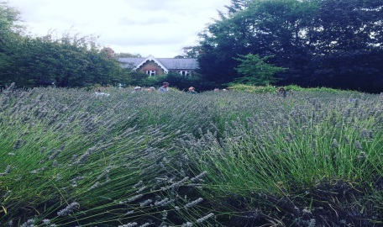
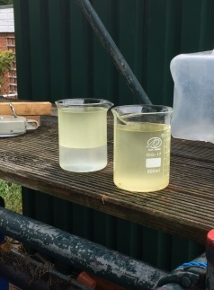
The final harvest from the current lavender plants was taken at the end of the Summer. Laurie Rudham once again allowed us to use the Carlshalton Lavender Field Still and we came home with 5 litres of lavender oil which will shortly be bottled up and sold at Italo on Bonnington Square. We are very grateful to Ruth Morgan for her help and the 100+ volunteer who took part in the harvest. The lavender plants will be replaced as part of the masterplan and the FOVP will be restoring and reinstalling the human sundial in a more central position in the field. The plants, which will again be of the Grosso variety, will probably not be mature enough to be harvested for another couple of years but we look forward to recommencing this popular event in the near future.
We have been looking for some time for a project to put the profits from the sales of the lavender oil towards. We have now commissioned Art4Space, a local arts company, to lead 3 workshops, open to the local community, to create a mosaic celebrating the story of the lavender in Vauxhall Park, which will be installed in the basin of the fountain

Model Village
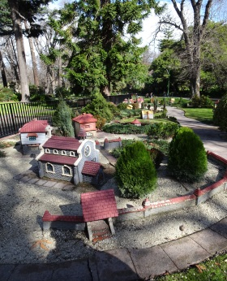
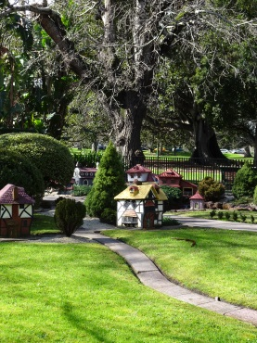
Our Committee Member, Polly Freeman, achieved a long held ambition when she was able to visit the twin to Vauxhall Park’s model village in Melbourne’s Fitzroy Gardens as part of a family holiday to Australia this summer. A sign in Fitzroy Gardens says ‘This model Tudor Village was presented to the City of Melbourne by the citizens of Lambeth England as appreciation of gifts of food despatched from Victoria to England during food shortages following World War Two’. Apart from the presence of possums, she said that looking at Melbourne’s village was exactly like looking at Vauxhall’s Village. Edgar Wilson who built our Village, also built ones for Finsbury Park and Brockwell Park. Unfortunately the Finsbury Park village was destroyed following vandalism and Brockwell only has four houses left (which can be found near to the Walled Garden). Melbourne’s village is the most complete and gives us an idea of what ours might have looked like. Melbourne’s contains a Church ( with stained glass, which a Model Village expert thinks might contain tiles from the burnt out remains of the Crystal Palace), a working Mill, Shakespeare’s and Anne Hathaway’s House, a pub, school, Toll house, walls and Oast houses. She met with a custodian of the Tudor Village and was delighted that the Village is obviously much loved and well cared for. Edgar would have been proud of the place that the village has in the hearts of the Melbourneites! A fuller report with more photos will be put on our website.

Green Flag
We were very pleased to hear that Vauxhall Park has been awarded a Green Flag for 2019/20. We would like to thank our volunteer gardeners in particular who work so hard to support Martin, Vauxhall Park’s gardener. 15 Lambeth Parks achieved Green Flag status this year and 3 open spaces were awarded Community Flags – a great vote of confidence in Lambeth’s wonderful open spaces.

Future Meetings:
Saturday 16 November 10.15am at the Bolney Meadow Community Centre
Wednesday 18 March 2020 8pm venue tbc
AGM Saturday 25 April 2020 10.15am Bolney Meadow Community Centre
Next Gardening Group: Saturday 23 November 9.30am at Parco

