Parks and Open Spaces

Strategic Plan 2020-2025
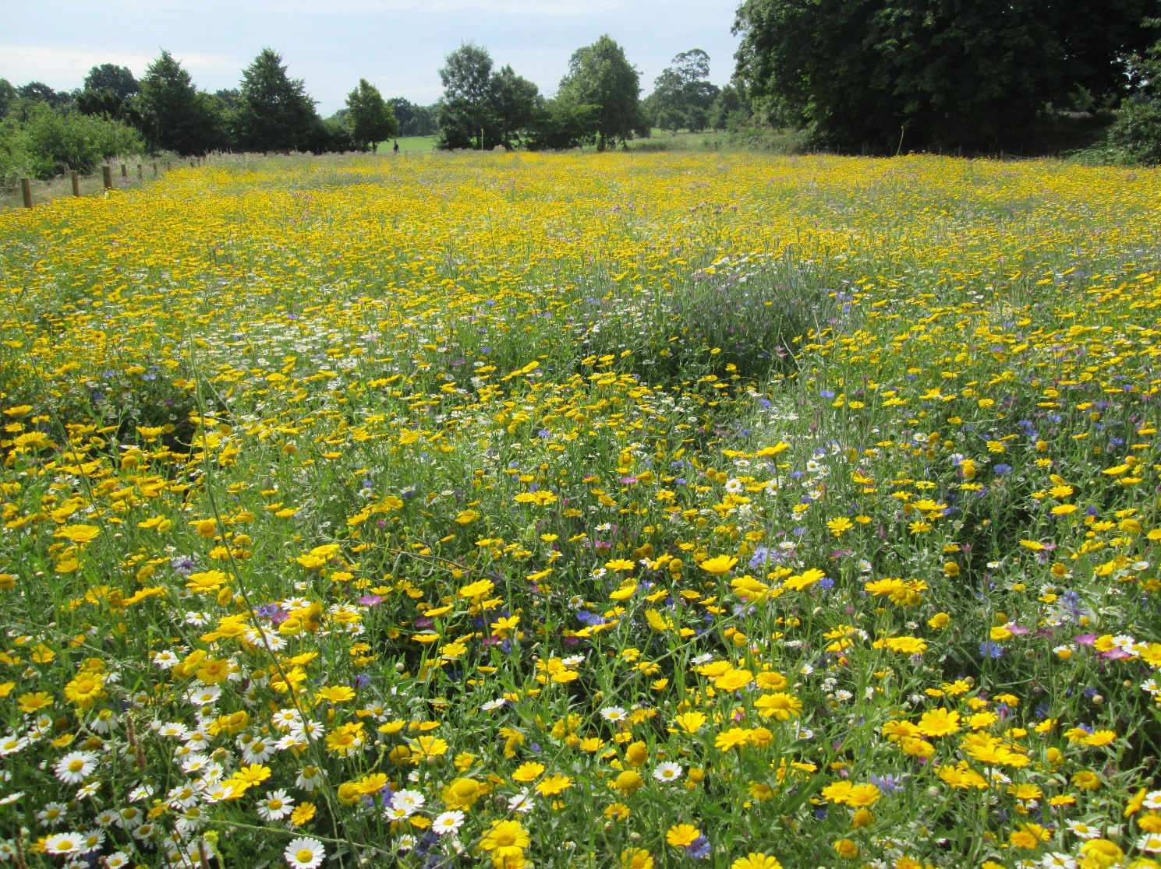

Lambeth’s Parks and Open Spaces – Strategic Plan 2020-2025

VISION

“To provide a diverse range of safe, well managed parks and open spaces that actively improve the quality of life for our residents and visitors.”

THE 10 STRATEGIC PRINCIPLES

These principles represent our strategic aims and delivering against them constitutes Lambeth’s Strategic Plan for parks and open spaces.

1 The Council’s Stewardship Role | 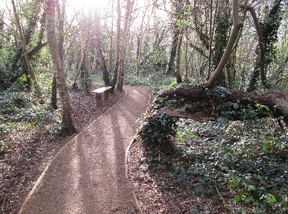

We will manage our parks and open spaces in the interests of the whole community. The Council is the ‘steward’ of Lambeth’s parks and open spaces and holds them in trust for the community and future generations. This role includes increasing the financial sustainability of the service

2 Our History and Heritage | 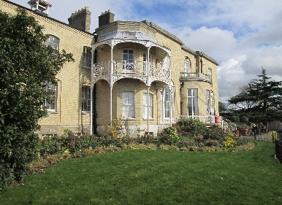

We will protect and conserve the historic landscapes and architectural heritage to be found within Lambeth’s parks and open spaces. We will ensure that this heritage is protected, now and for the future

3 Parks and Open Spaces as Community Assets | 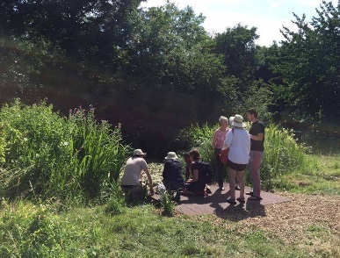

Lambeth’s parks and open spaces are an essential and inalienable community resource. We will encourage community events and work in partnership with local people, involving them in the decision-making processes relating to the use, development and management of the borough’s parks and open spaces

4 Investing in Our Parks and Open Spaces | 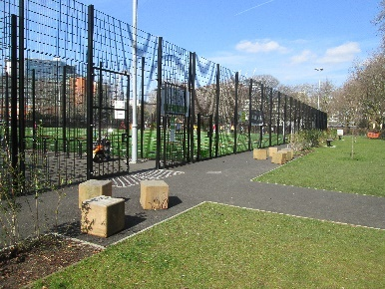

We recognise that our parks and open spaces require investment and nurturing. We will actively seek opportunities to generate income and secure funding for the improvement and regeneration of our parks and open spaces, in partnership with key stakeholders and external agencies

5 Universal Access to Parks and Open Spaces | 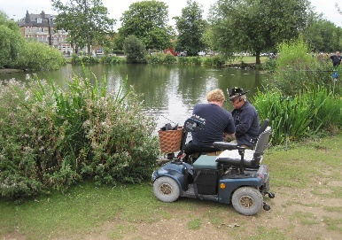

Lambeth’s parks and open spaces are there for use by everyone. We will support and promote fully inclusive access and use of Lambeth’s open spaces for the benefit of the whole community; improving accessibility where resources permit. We will also improve access to information and services

6 The Right to Safety | 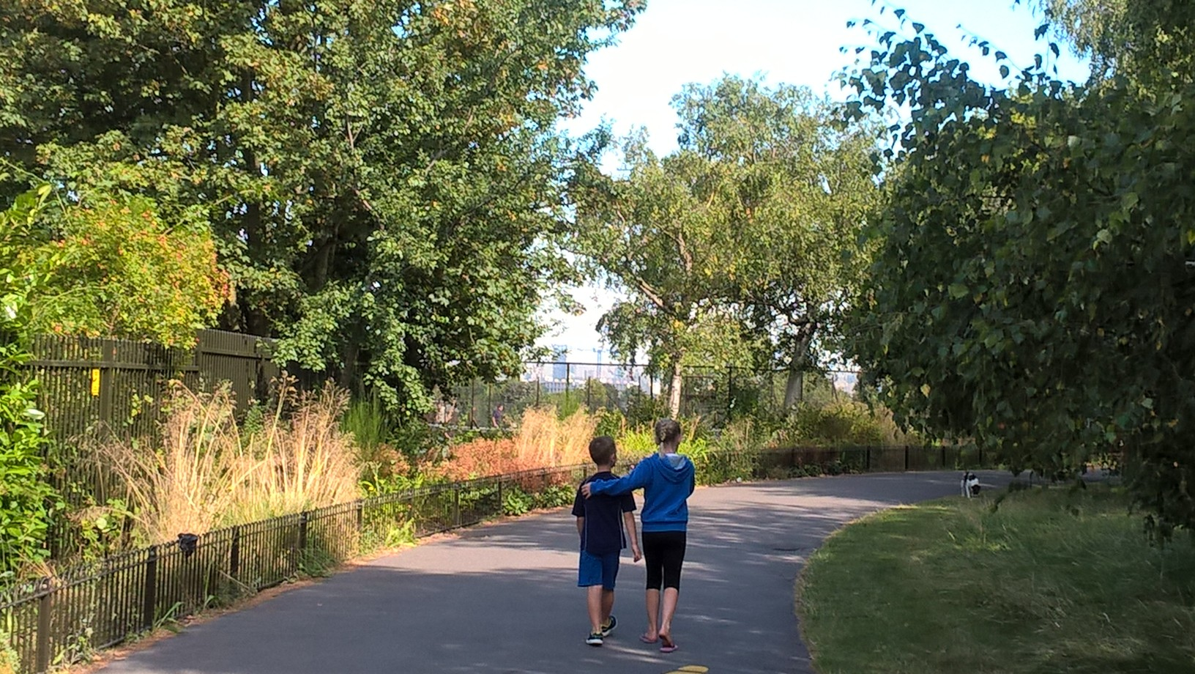

Our users have the right to visit Lambeth’s parks and open spaces in safety and without fear of crime. We will work in partnership with key stakeholders and partner agencies in order to provide healthy, safe environments

7 Education, Art and Culture

We will encourage the use of our parks and open spaces as important centres of education as well as places to celebrate Lambeth’s historic, cultural and artistic diversity. We will aim to facilitate a full and diverse range of events, in line with the new Events Strategy 2020-2025

8 An Active and Healthy Borough | 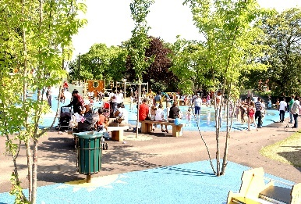

Our parks are crucial for improving health and wellbeing through physical activity, play, relaxation and contemplation. We will maximise these opportunities as resources allow, working with a wide range of partners to improve and develop facilities; with a focus on expanding our play offer

9 Promoting Biodiversity and Sustainability | 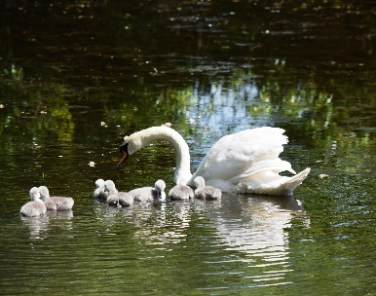

We will protect and enhance biodiversity and actively promote nature conservation. We will aim to make our operations as sustainable as possible, increasing recycling opportunities, reducing the usage of non-renewable resources and minimising the use of pesticides and other chemicals. We will actively contribute towards Lambeth’s broader sustainability objectives

10 Aiming High – Ensuring Quality | 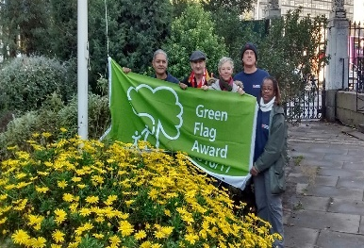

We will make best use of our resources to ensure the highest quality service possible for all our open spaces. We will invest in our staff, strive to achieve Green Flag accreditation across all appropriate sites over one acre in size and actively participate in London in Bloom and other accreditation schemes

Delivering Against the Strategic Principles

The following list details the actions we will take to ensure we deliver against our ten strategic principles. Specific actions will be included within the annual Service Development Plan for Neighbourhoods

Principle | Key Delivery Commitments 2020 to 2025
1. The Council’s Stewardship Role | Undertake an annual user survey and use the results to tailor our management and investment actions and priorities  Create an individual management plan for each site managed by Lambeth, either a five-year plan for Green Flag sites, or a three-year plan. These management plans will provide the detail on how our strategic principles will be delivered at a local level  Produce a Grounds Maintenance Specification document, which will be reviewed annually  Seek to secure Deeds of Dedication with Fields in Trust for at least five parks  Work with Legal Services and Planning to deal robustly with any unauthorised occupation of, or damage to, public open space  Work with Legal Services and Planning to protect public open space from inappropriate development  Invest in training and development for our staff and promote horticulture and parks maintenance as a career choice for Lambeth residents  Seek to bring as many sites as possible under active management as public open space and create new public open space in areas of deficiency  Achieve a balanced budget for the service through constantly reviewing and reducing costs and increasing income  Actively seek external funding to improve the service offer and mitigate the effect of budget cuts  Develop a Tree Strategy  Work with Property Services to bring all buildings in parks into active use through lease arrangements, reinvesting income back into the parks service  Seek innovative ways to manage our parks which bring financial or other benefits
2. Our History and Heritage | Record all Listed assets  Arrange for condition surveys as appropriate  Prioritise conservation for structures on the Heritage at Risk Register (HARR); aim to remove all Listed assets from the HARR  Develop a funding plan for all Listed assets needing remedial works  Apply for Listed status for additional assets meeting the appropriate criteria  Ensure appropriate actions are built into management plans and Masterplans  Develop Landscape Conservation plans for Listed Parks and Gardens
3. Parks and Open Spaces as Community Assets | Develop a Memorandum of Understanding with the Lambeth Parks Forum  Actively support the Lambeth Parks Forum and use the Forum as a conduit for consultation with stakeholder groups  Encourage the creation of new Friends groups and help groups to develop robust and sustainable structures through a model constitution and mentoring  Provide named contacts to all Friends/stakeholder groups for operational and developmental issues  Create Partnership Boards for larger sites where there is the demand to do so  Support stakeholders and community groups to undertake partial or complete management of individual sites where this reduces the financial liability and resource input for Lambeth; and adds value over and above our core service offer  Provide support to stakeholder groups with applying for external grants  Engage with stakeholders over the creation and development of management plans  Create and implement a Volunteering Plan, maximising opportunities for people to get involved with the maintenance and management of our parks  Work with Housing to develop the potential of Lambeth Housing land for public amenity and nature conservation
4. Investing in Our Parks and Open Spaces | Complete implementation of the Parks Capital Investment Plan, actively seeking out funding opportunities supported by a dedicated Fundraising Officer  Actively pursue external funding as our priority funding stream  Seek to apply for and utilise S106, CIL and NCIL in a strategic way to support priorities under the Parks Capital Investment Plan  Increase the financial benefit to parks from events income  Focus on making parks feel more welcoming through enhanced entrances and improved signage
5. Universal Access to Parks and Open Spaces | Commission an access review for park facilities and seek funding for implementing recommendations  Ensure accessibility is factored into all new capital projects as appropriate  Provide accessibility information about our parks online  Contribute towards implementation of the Equality Commission’s recommendations  Improve our digital offer for park users
6. The Right to Safety | Fund one of the Partnership Plus officers forming the new Public Realm policing team for the initial three-year agreement  Seek opportunities for increasing the presence of other enforcement officers within Lambeth’s parks  Work collaboratively with the Safer Streets commissioning team and outreach officers to address rough sleeping  Seek to implement a Public Spaces Protection Order covering all appropriate public open space to provide a more flexible way of enforcing byelaws and additional opportunities for enforcing against anti-social behaviour  Maintain existing lighting within parks, dealing promptly with defects  Continue with quarterly inspections of play area and appropriate mechanisms to address and rectify identified risks in a timely manner  Develop a risk management policy covering trees in parks  Seek to respond to safety concerns robustly, working with partners to implement solutions where reasonably practicable
7. Education, Art and Culture | Encourage use of parks by Lambeth schools for educational activities  Seek partnerships with schools to take on park-based projects and activities  Work with Arts colleagues and cultural partners to increase public art and cultural offerings within our open spaces  Provide financial support for free bandstand programmes organised by stakeholders  Provide event planning and management support and training to community groups  Facilitate a wide-ranging and diverse programme of events
8. An Active and Healthy Borough | Prioritise play within the Parks Capital Investment Plan, improving and expanding play opportunities  Implement the Lambeth Local Football Facility Plan  Implement relevant actions under the Active Lambeth Plan and Outdoor and Indoor Sports Strategies  Complete implementation of the Health Parks pilot in Ruskin Park and roll-out to other parks  Work closely with Public Health on relevant initiatives  Expand the opportunities for sport and physical activity through improving and expanding the range of facilities, activities and guided trails  Actively support community sport initiatives to maximise opportunities, particularly for target groups within Active Lambeth, including young people  Promote and support allotments, community gardens and orchards as part of an overall approach to healthier living  Proactively manage a licensing scheme for personal trainers to ensure those using parks for training are providing a safe and professional service
9. Biodiversity and Sustainability | Implement the action plan linked to our Biodiversity Action Plan (BAP)  Deliver against the Green Infrastructure Strategy  Include BAP objectives within all Management Plans  Implement the 2019 SINC review  Where resources allow commission studies to assess existing biodiversity value of our sites and make recommendations for enhancing  Increase opportunities for residents to have access to nature  Promote and develop green corridors between parks for recreation, nature conservation and sustainable transport  Work with Highways to increase the biodiversity value of Highways land, including de-paving areas to create new green and wildlife verges  Implement our Integrated Pest Management Policy  Increase recycling and composting facilities  Avoid all peat-based products  Reduce use of single-use plastics  Increase battery-operated equipment  When replacing vehicles purchase models with the lowest environmental footprint possible, compatible with operational requirements  Tailor management where appropriate to contribute towards Lambeth’s carbon neutral pledge  Promote management policies which help combat climate change  Fulfil our role in Lambeth’s Air Quality Action Plan  Tailor management where practicable to enhance the value of our open spaces in improving air quality  Create a Pollinator Action Plan  De-pave hard surfaces where they are no longer essential, returning land to soft landscaping, with a focus on biodiverse planting where possible  Seek to procure goods in accordance with Lambeth’s Responsible Procurement policy wherever possible
10. Aiming High – Ensuring Quality | Gain Green Flag accreditation for all 32 parks and open spaces falling within our eligibility criteria  Proactively participate in London in Bloom and aim to increase the number and standard of awards each year  Work to improve Lambeth’s score under the Good Parks for London report. The 10 scoring criteria provide a measurable benchmark for the quality of local authority parks services  Aim to remain within the top five performing boroughs under the Good Parks for London Report  Achieve FTA Van Excellence annually  Achieve FORS Bronze  Maintain a suite of Key Performance Indicators for the parks service, reviewing targets annually and reporting publicly through a quarterly performance report

Lambeth’s Borough Plan 2019-2021

Through this strategic plan our Parks service contributes to Lambeth’s Borough Plan priority of:

Making Lambeth a place where people want to live, work and invest

Specifically, the goal of:

We will maintain Lambeth’s award-winning parks, and invest in a wider network of green spaces to support community activity and wellbeing

In addition, this Strategic Plan will contribute to the following Borough Plan goals:

We will work to achieve sustained reductions in serious youth violence

(by providing safe neutral spaces for young people to play, socialise and undertake a range of leisure activities; and by supporting community-based groups and organisations to run diversionary activities within parks)

We will invest in the assets that our communities need to be healthier and more resilient

(through ongoing capital investment across parks and open spaces)

We will improve the mental health of Lambeth residents and council staff, focusing on those at greatest risk (by increasing usage of our parks - extensive research confirms the benefits to mental health from spending time in parks)

We will support people to live longer and healthier lives

(again, a large body of evidence proves the multiple health benefits achieved from spending time in parks, whatever the activities undertaken)

