FRIENDS OF VAUXHALL PARK NEWSLETTER No. 36

Registered Charity 1166894 www.vauxhallpark.org.uk

New Chair and Committee
At our 2020 AGM, Charles Vyvyan who served as FOVP Chair for five years and led us through the delivery of the improvement works, stood down. We thank him for his enormous contribution to the Park and to the work of the Friends group. We are delighted to welcome local resident John Roome as our new Chair. We also welcome Lyn Woodcraft to the FOVP Committee as Treasurer. Lyn replaces Helena Lewis who we thank for all of her hard work keeping the FOVP accounts in order over many years. Clare Church, who served as FOVP Secretary amongst other roles has also retired from the Committee. We thank her for her contribution and welcome Mandy Knight who is now FOVP Secretary.
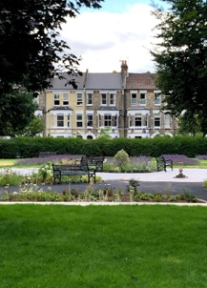
Vauxhall Park Masterplan
We are delighted that the improvements to Vauxhall Park are finally (just about) finished. There is inevitably, quite a long list of ‘snagging’ items which we will continue to pursue with the Lambeth. The tennis court resurfacing works were recently completed and we look forward to the nets and lines being replaced. We are delighted by the result of all of the hard work put in and look forward to seeing the new planting maturing over coming years.

Vauxhall Masterplan Phase II
The wider improvement works in the Park have highlighted the perilous state of the green building in the middle of the Park. Lambeth Council have allocated funds from their Capital Investment Programme to tackle its future as Phase II of the Masterplan. A Steering Committee made up of representatives from both Lambeth Council and the FOVP are working on what it’s replacement might be. The hope it is to demolish the current building, which is beyond economical repair, and replace it with a building of smaller footprint both in size and environmentally friendly. This will have the benefit of opening up access to the large green space at the rear as a quiet play space for under 5’s. We will be consulting on the plans coming forward: please keep an eye on park noticeboards and on FOVP social media feeds for further information and to comment.

Gardening Groups
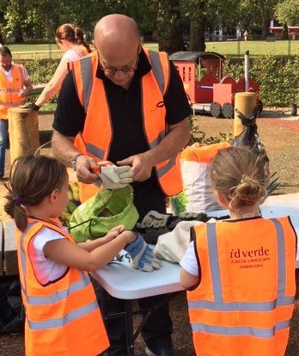
Regular volunteer gardening groups have been working hard, with Covid restrictions being observed, over the past few months. They were supported by resources (including 3000 spring bulbs and gardening tools) given by Idverde, the contractor for the improvement works. We were delighted by the enthusiasm of local families and their children to help out. If you would like to join in with future groups, please email friends@vauxhallpark.org.uk. In the meantime, please keep off the planted areas and beds around trees as the spring bulbs we planted start to appear!

Conservation Area
A quiet area has been identified as a Conservation/Wildlife area which we will be working to create over the next few months. In consultation with Lambeth’s Conservation Officer, we have drawn up plans to encourage more insects, birds and other wildlife into the Park. This will be a restricted access area to allow the wildlife to flourish but we plan to hold events for children in particular to come to learn about the importance of areas such as this. The creation of this area will support the Park’s value when it is judged for the Green Flag and London in Bloom Awards.

Lavender Mosaic
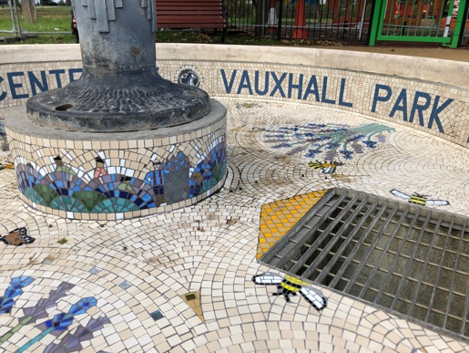
As part of the improvement works a mosaic, celebrating the contribution that the lavender field has made to the Park, has been installed in the fountain basin. Created by the London School of Mosaics during the summer of 2020, the mosaic features the harvesters, the Still at Carlshalton lavender field where the oil is distilled out of the flowers, Victorian lavender bottles, a lavender scythe. See if you can spot Laurie ,who lets us use the Carshalton Still, with his red braces! We are pushing Lambeth Council to make sure that the pump is in working order for when water features in Lambeth Parks are switched on again.

Parco Café
After seven years of tempting us with delicious coffee, teas, cakes, lunches, breakfasts, beer and wine, Domingos has left Parco Café. We will miss him and his family but would like to welcome Ardian and Mimoza who have taken over the lease. We are very much looking forward to what they will do with this wonderful park asset. Please go to say hello and support them!

The Surprising History of Vauxhall Park
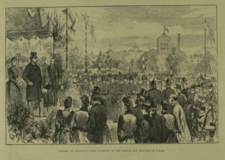
As part of Lambeth Libraries series of talks to entertain us during the lockdown, FOVP Committee Member Polly Freeman gave a virtual guided tour of the history of Vauxhall Park. Her talk brings together the many extraordinary stories which includes a link to Australia, Royalty, Suffragists, vinegar and Charlie Chaplin. The talk is on our website www.vauxhallpark.org.uk/history and it can be used for a self-guided walk.

This Photo by Unknown Author is licensed under CC BY-NC
This Photo by Unknown Author is licensed under CC BY-SA

