On line talk given by Polly Freeman hosted by the Tate South Lambeth Library 11/11/20

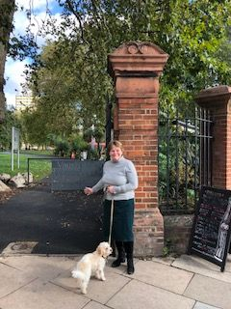
Hello and thank you for joining me tonight.

Even though it’s dark outside now, I’d like you to try and imagine that it’s a beautiful sunny day (I’ll leave the choice of season to you!) and we are standing by the gates on the corner of the South Lambeth and Fentiman Roads, leading into the Park. For those of you that have come on the actual walk that I have led around the park previously, I promise you that I have some new information.

As we stand here, I’d like to bring to your attention to these gates which we’re very proud and protective of, for a good reason. They were designed by C Harrison Townsend, the architect of the Horniman Museum in south London and the Whitechapel Art Gallery

Just before we go inside the Park, as it’s Remembrance Day, I’d like to pause, for a moment and reflect on the many members of the community who took their leisure in the Park, but sadly did not return from their service, the solace that the park would have provided for the families of those that were killed, and the respite, I hope, it would have bought and, continues to bring, to those damaged by conflict.

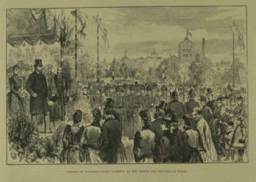
Before we set off round the park but as we pass through the gates if we had been here on 7 July 1890, a very different scene would have greeted us: The Prince of Wales, the future Edward VII and known as Bertie, the Princess of Wales, their daughters Princesses Victoria and Maud, Bertie’s brother, the Duke of Edinburgh, his sister Princess Louise, who was Vice President of the Kyrle Society (more of them later) were seated on a platform alongside the Archbishop of Canterbury, with the Surrey Regiment providing the Guard of Honour, to open Vauxhall Park. On the platform were Millicent Fawcett, the great Suffragist who fought for women’s right to vote, now honoured with a statue in Parliament Square with her daughter Philippa, who that year had become the first woman to obtain the top score in the Cambridge Mathmatical Tripos exams, Octavia Hill – Social Reformerm co-founder of the National Trust and of the Kyrle Society, Fanny Wilkinson the designer of the Park and the first professional female landscape designer, Emma Cons – another great Social Reformer who campaigned for educational opportunities for the working class including cheap tickets to performances at the Old Vic Theatre, along with other local dignitaries including Mark Beaufoy, owner of the nearby Vinegar Works (more of him later too). It must have been quite a sight … But why? Surely this is not normal for the opening of a Park?

Well, I have a story to tell!

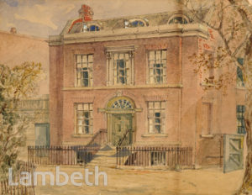
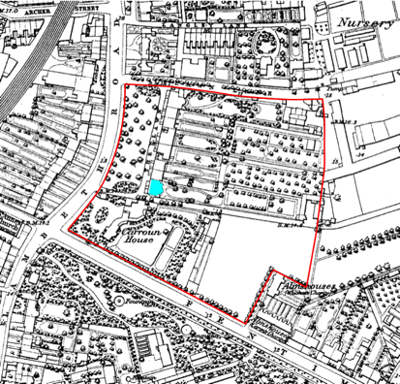
In the mid 1800s, the land that the Park now occupies looked like this. This area, was home to industries including vinegar works, brewing, candle manufacturers, gas works and of course the Doulton Pottery. There was increasing awareness of the need to improve the living conditions endured by the poor and their lack of access to open space. Luckily for us, Henry and Millicent Fawcett had been leasing 51 South Lambeth Road, on what was known as the Lawn Estate. Their house is marked in blue on the map and, the house on the slide you are looking at, is their house. You can see the extensive back gardens that they and their neighbours enjoyed. It looks pretty good. Henry, an MP, could walk to Parliament from here and enjoyed being able to hear (as he said) ‘real birds and the sound of wind among real leaves’. I can’t possibly capture tonight the importance of Millicent, but during her time in Vauxhall, she was increasingly involved in the campaign to give women the vote and, the circle of friends that their home’s central location would have attracted, I imagine, would have made for some fascinating evenings. Oh to have been a fly on their wall! On her memorial in Westminster Abbey it says ‘A wise, constant and courageous Englishwoman. She won citizenship for women’.

They lived here until Henry, an eminent politician and academic, died tragically young at the age of 51. However, the housing conditions for most people in the area would have been desperately overcrowded and unsanitary. The Fawcetts would have been extremely aware of the wider conditions of the area, and it was a long held ambition of theirs that the local people had access to quality open space. After Henry’s death in 1884, Millicent moved away but when the area, outlined in red, came up for sale and was under threat of development, she became involved in the campaign to create a park.
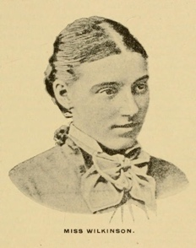
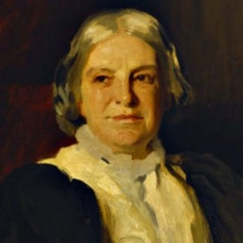
Besides Millicent’s sister Elizabeth Garrett Anderson, who was the first female physician and surgeon, in Millicent, and Henry’s, orbit of friends were many extraordinary people such as the Hill sisters, Miranda and Octavia who had founded the Kyrle Society whose aim it was to bring beauty to the poor. They actively reclaimed disused open spaces and created new ones for the express benefit of the poor and their patron was Queen Victoria’s daughter Princess Louise. When the Lawn Estate came up for sale, the Kyrle Society launched a campaign to create a pleasure garden in Henry’s memory, instead of the proposed speculative housing. Octavia Hill was an influential social reformer and one of the first housing reformers to understand the benefits of open space to (and I quote) ‘give grass, trees and air; to the poorest inhabitants of cities. Octavia, as I have said, went on to co-found the National Trust. Another member of this group of influential women was Fanny Wilkinson, who as previously noted, was the first professional female landscape designer. She was employed by the Kyrle Society to transform the overgrown areas they had obtained into public spaces and later in her career, started what was to become the ‘dig for Victory’ movement to provide food during World wars 1 and 2.
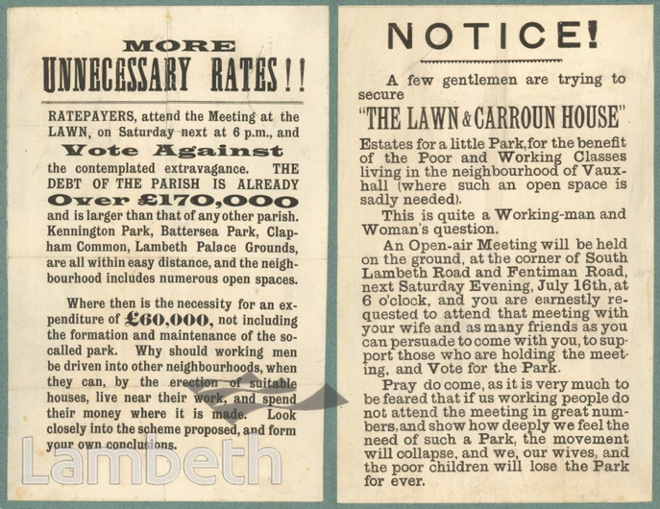
The plans for Vauxhall’s park were not without controversy
These handbills which I’m now showing you, courtesy of the Lambeth Archives, give you a flavour of those in support and those against. Other sources have given me some wonderful quotes:
‘The neighbourhood is a crowded one. The land in question is the last open space in the district. If this opportunity is lost, it is lost forever’
And
‘inhabitants of richer neighbourhoods who themselves enjoy so much larger a proportion of space, inside and out and who leave town every summer, are earnestly solicited to complete a scheme which their poorer fellow citizens have, by much labour and sacrifice carried so far.
Opponents thought that the scheme was ‘contemplated extravagance’ spending a great deal of money on a park when housing was needed. I’m not sure that the housing that would have been built would have been within the means of many ordinary Londoners … sound familiar?!
It was hard going raising the money for the Park and tensions within the community were high. John Cobeldick, the developer who had bought the land was persuaded to sell all eight and half acres to the Metropolitan Board of Works (which became the London County Council) and the land was purchased under a special act of parliament – the Vauxhall Park Act of 1888. Money came from various other sources including the Lambeth Vestry, Charity Commissioners, Mark Beaufoy and various other people.
Mark Beaufoy was particularly important to the creation of Vauxhall Park as he paid for the maintenance of the Park for the first 3 years, and paid the interest on the loan taken out to purchase the land. A local unsung hero indeed.

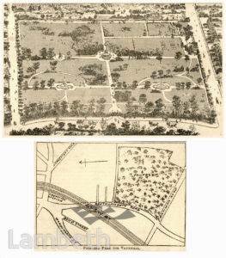
I’m showing you here a plan of the original proposed layout of Vauxhall Park which makes it look very grand.
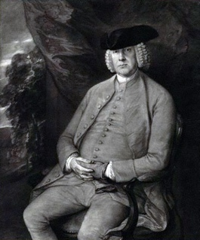
If you will forgive me, I can’t let this occasion pass without saying a brief(ish) word about Beaufoys. Unfortunately I haven’t been able to find an image of our Mark Beaufoy but it was his grandfather, Colonel Mark Beaufoy who lived from 1764 to 1827 whose image I did find and is on this slide, his father, also Mark Beaufoy, established the Beaufoy vinegar works in Waterloo. Colonel Beaufoy was an astronomer, explorer, mountaineer and physicist. He was the first known English climber to reach a high altitude and the fourth person to ascend Mont Blanc. He devoted much of his life to nautical experiments including measuring tide meter, the affect of the wind on sails both of ships and windmills and was instrumental in reducing the rolling motion of ships’ hulls. I’m sure ship’s passengers would have been very grateful for this. His work was taken up by Isambard Kingdom Brunel. His son, Henry Beaufoy, moved the vinegar works to 87 South Lambeth Road, next to where Vauxhall Park now is, and established the Ragged School in Lambeth which was on Black Prince Road. Henry’s son, our Mark Beaufoy, subsequently took over the family vinegar business. He was variously a Liberal MP, Chairman of the Kennel Club and published A Father’s Advice, a basic safely manual for game shooting, including the phrase: If a sportsman true you’d be, listen carefully to me. Never, never let your gun, pointed be at anyone’.. This book was so successful that it was given away by gun merchants especially to young gentlemen being given their first gun. Mark had three sons; George, the middle one, was killed, with I imagine many employees, when a bomb fell on the vinegar works in 1941. This area was hit multiple times during the Blitz as it was so close to the Nine Elms railway marshalling yard, so tonight we also remember the civilian victims of war. The Beaufoys firm is now part of British Vinegars Ltd which includes Sarsons Malt Vinegar. I defy you not to think of Vauxhall Park next time you sprinkle some vinegar on your chips!

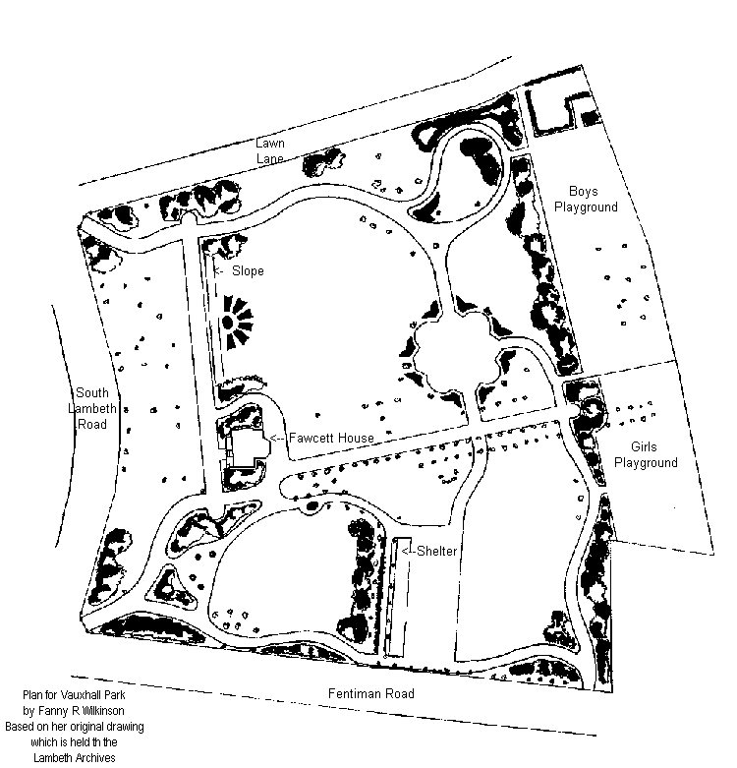
So, the land was secured and Fanny Wilkinson was employed by the Kyrle Society to create the Park. I’m here showing you her original design, alongside the park as it is today. I find it fascinating that the boys and girls had separate playgrounds originally! There are other maps on the FOVP website if you are interested in seeing more details about how the park layout has changed over the years. But you will see that the park has not changed so very much for her original intentions. If you look very carefully at the top of both maps, the path which runs along the northern edge of the Park and parallel to Lawn Lane runs along the same trajectory now but this is something we have changed recently. Look at where the line of trees curve on today’s map. This path had been altered over the years so it ran right alongside the northern boundary, which didn’t make for a very pleasant experience. It gave me enormous pleasure that, during the recent improvement works in the Park, this path was altered to reflect Fanny’s original path layout. I think we should name it Fanny Wilkinson Avenue. Fanny Wilkinson, soon to be honoured with a blue plaque on her house in Gower Street, is a fascinating character and deserves a whole lecture to herself. She designed many of London’s open spaces including Myatts Field Park; if you have time, I urge you to google her which should direct you to a lecture about Fanny on You Tube, given by Elizabeth Crawford.
So, that’s the history of why Vauxhall Park is here today and now I’d like you to follow me as we start our virtual walk around the Park. On my virtual tour of the Park we will be starting at the bottom left hand ( or SW) corner of the park and then heading north before moving around it in a clockwise direction.
We first pass Parco, transformed from a disused public toilet about ten years ago due to the persistence of our then Chair, Ivan McCracken and now a thriving café and centre of park life.
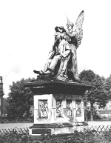
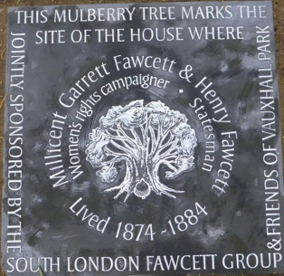
As we walk north, along the path which would have been the road in front of the Fawcett’s House, and keeping the newly upgraded dog area on our left hand side, we come to a plaque to Millicent and Henry Fawcett. This is on the site of their house and of a magnificent statue of Henry, a titan of his generation. The Statue was given to the Park by the local Doulton Pottery and designed by Henry Tinworth, a mastercraftsman of the factory. Henry is seen being crowned by Peace and there are beautiful friezes around the base of the statue which, I believe, depicted scenes from his life. The trees in the background an idea of just how big this statue was. I will talk a bit more about Henry later on in our tour. Astonishingly, Lambeth Council decided that the statue had to go and the whole thing was demolished in the 1950s. Local legend has it that the head of the statue is in the entrance of the Henry Fawcett Primary School, behind the Oval cricket ground, but opinion differs. In 2013, the FOVP were approached by the Fawcett Society we were delighted to co-sponsor this plaque to mark our connection to the Fawcetts and Millicent in particular (we beat you to it Parliament Square!). It was created by Fiona Haugh.

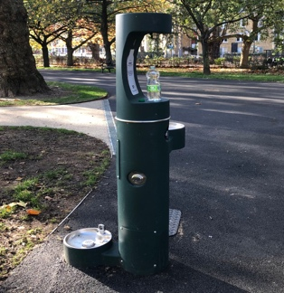
Moving on the round the Park, we pass our amazing new drinking fountain which has three watering points: one to fill up your drinking bottle, one for humans and one for dogs. We fought hard to have environmentally friendly solutions installed as part of our improvement works .. so long plastic bottles! I’m afraid, for those of you who decided that we were walking in a winter month, the water is only on in the Summer months
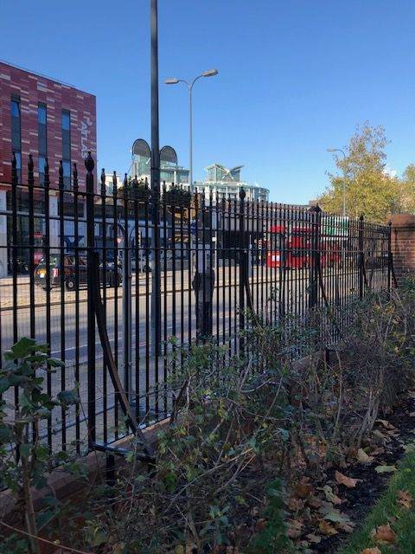
We are also delighted that the missing stretch of railings, along the South Lambeth Road, is being replaced and, if you look to your left, you will see the workers from Idverde, who were the contractors creating our beautiful improved park, hard at work installing the last of the panels. The railings around the Park were all taken away as part of the call for scrap metal to build Spitfires, or was it warships, during the second world war. The Friends have been instrumental in replacing railings on the other boundaries but are very grateful to Lambeth Council for completing the job!
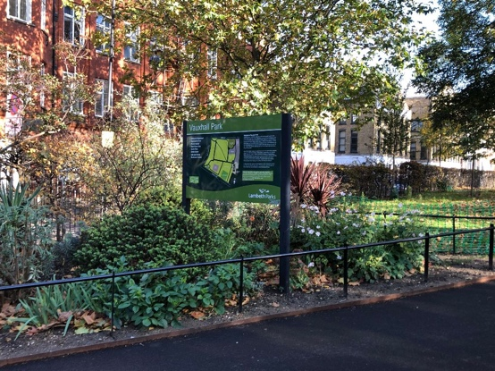
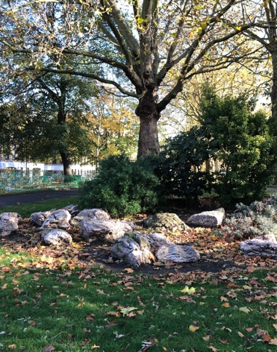
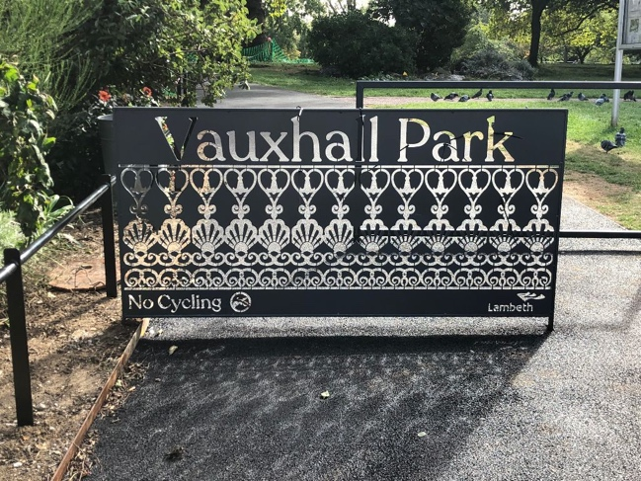

The beautiful planting that you would have noticed by entrance gates, is looked after by the FOVP volunteer gardeners, and they would be delighted to see you if you’d like to join in with their next get together. The new cycle barriers, pick out the design of the metal pergolas which used to be in the playground. We have collected together the various rocks that were dotted around the park in our new rockery: I have been told that these rocks are very important but we haven’t been able to find out why. They are not pulhamite but, while we wait to see if we can find out any more about them, they have provided a much better setting for this bed which our volunteer gardeners will be working on. We are lucky enough to have two dog areas, so if you arrive to find a rather fearsome looking dog in one area, you can safely use the other. We love our four legged friends to be in the park but please. not in the Fawcett Garden or Playground.

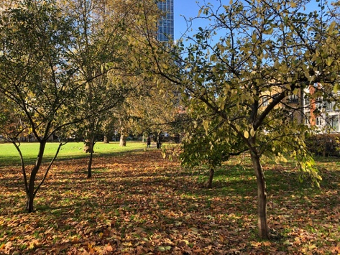
As we walk along ‘Fanny Wilkinson Avenue’ we might feel the rumble of the Victoria Line passing underneath as the Community Orchard comes into sight. In fact you can see the sweep of this new path in this photo. The second tree we pass, is a very special Vauxhall apple tree, cultivated in a nursery on the Wandsworth Road in Victorian times, I believe. The orchard was given to the park by the Orchard Project, a wonderful charity which encourages orchard planting across cities. It was planted by the community and we have apple and pear trees, medlars, mulberries and cobnuts. This orchard is for the benefit of the community and, one day, I will be quick enough to sample a Vauxhall apple!
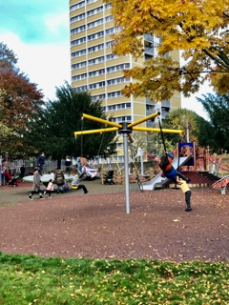
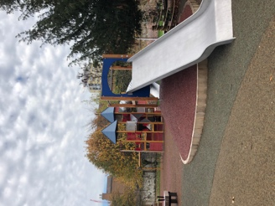
A major attraction of the park is our playground. When I first came to the park with my young children in the late 1990s, the playground was a very sad place. Desperately outdated and run down, it was nevertheless much loved by local children, especially the train. I was seriously concerned that it might be listed as an example of a 1970s or even 1960s, playground (only joking) so was delighted when, as part of the recent works, we were given a playground that caters for all abilities, and a much wider age range. It’s wicked, as I heard one playground user saying. If anyone is concerned about the future of our society, can I suggest that they just spend some time in our, or any, playground and they will see children of all ages, races and abilities playing happily side by side, cooperating together to make the equipment work.

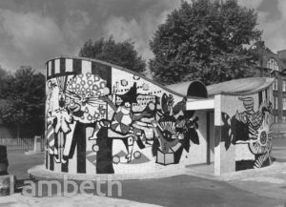
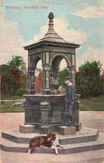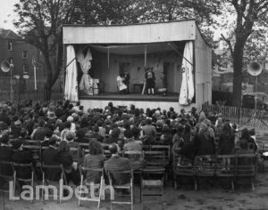

A trawl through the Lambeth Archives gives us a fascinating glimpse of the park over the years – the public convenience, now long gone, had a mural created by Tony Hollaway who created the stained glass windows in Manchester Cathedral, happily still there. The outdoor theatre entertained children in the 1940s, I think and looks to be great fun and I love this very splendid drinking fountain. We know that the Doulton Pottery gave a drinking fountain to Vauxhall Park at the same time that the Henry Fawcett Statue was installed so this may be a photo of it. It’s quite different from our new one!

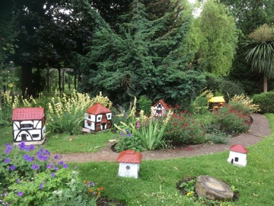
As we pass the playground, walking South, we see the Model Village. This, almost, unique village was created by Edgar Wilson who lived in Norwood in the 1930s. I understand that model villages were quite a thing in those days and he created one for Brockwell Park, ours and one for Finsbury Park.

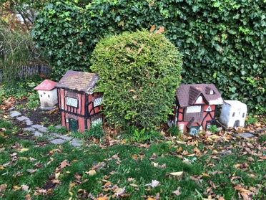

This is all that is left of Brockwell Park’s today but it is much loved and looked after by the Friends of Brockwell Park.

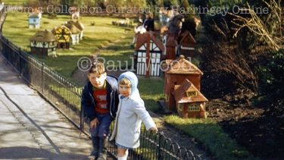
Sadly, Finsbury Park’s village was vandalised, then removed by the Council and destroyed.

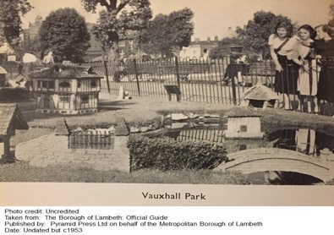
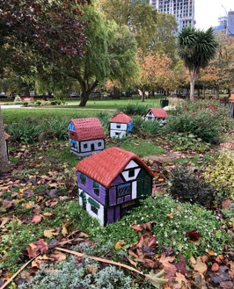
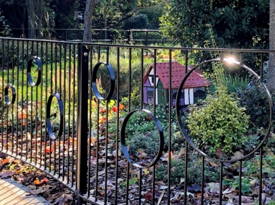
Our village was originally much more extensive as you can see in the black and white photo but what is left is a greatly treasured by us today and expertly looked after by local resident Nobby Clark. Nobby has, in recent years, painted the houses to reflect important events – the Suffragette colours of purple, white and green, are to mark 100 years of women’s suffrage. Maybe Millicent Fawcett’s less militant Suffragists’ colours of Green White and Red, which spell out Give Women Rights, can be used next time the paint brush comes out. This year, one of the houses was painted blue, to honour the NHS. We have nine houses left and, to showcase the village, our improvement works have cleared away the inappropriate planting that had grown up around the houses. There are now some bespoke railings in front of the houses which, I hope, will encourage children to peek through, and imagine who might be living in those houses.

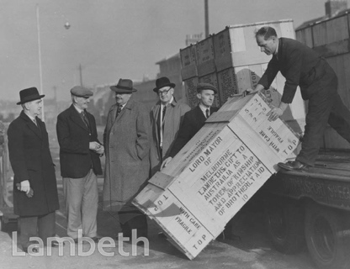
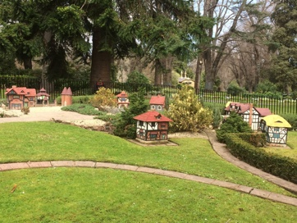
However, that is not the end of the model village story: During the second world war, food parcels were sent from Australia to Lambeth residents. Edgar Wilson was so grateful that he did, well what else would he do, he made them a model village. He is second from the left, in the flat cap, next to the Mayor of Lambeth. All one tonne of it was sent out, the delivery cost paid for by P&O, and it was installed in Melbourne’s Fitzroy Gardens. I was lucky enough to visit Melbourne and, honestly, was very confused. Looking at their village, I could have been in Vauxhall Park, if it wasn’t for the possum eyeing up my Lamington cake.
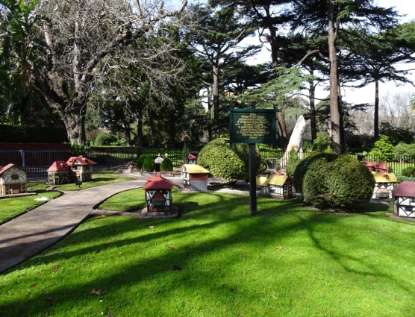
The sign in this picture says “This Model Tudor Village was presented to the City of Melbourne by the citizens of Lambeth England in appreciation of gifts of food dispatched from Victoria to England during food shortages following World War 2’. If it is possible, I have to admit to Model Village they have Shakespeare’s House, a working Mill, church, toll house, school, Anne Hathaways’s house, a pub, The Pilgrim’s Rest and some Kentish Oast houses.

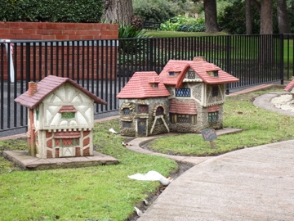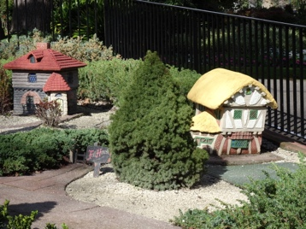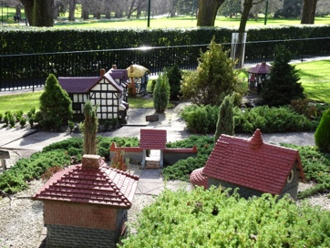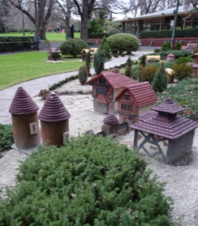

I was absolutely delighted to see that their village is in really good condition and spent a happy afternoon (much to my daughter’s embarrassment), talking Model Villages to a representative from Fitzroy Gardens. Who knows, a twinning may come about!

I know that the Finsbury Park Model Village was called Otford, after the village near Sevenoaks in Kent which, coincidentally, or spookily, is near to where my family lives. Here are some photos of houses in Otford and an oast house
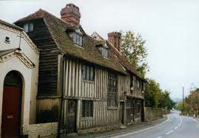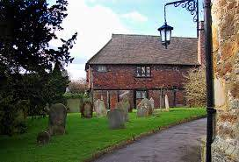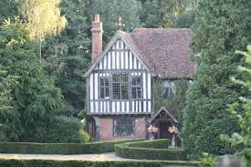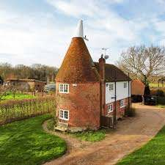

One day, I need to do some research about a possible connection between Edgar and this area.

As the Pilgrim’s Way Path, which runs from Winchester to Canterbury, passes through Otford, I’m guessing that naming the Fitzroy Garden’s pub, The Pilgrim’s Rest, also gives us a clue that Edgar had some sort of connection to this area, not far and a short train journey, from his home in Norwood. I wonder if the Vauxhall Park village had a name?

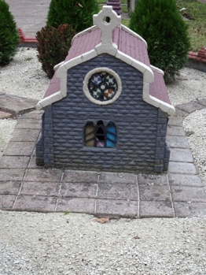
I have one more nugget of information about the village. Some years ago, Brian Salter who was writing a book about model villages came to the park. We wandered around the houses and he told me that he reckons that Edgar ‘recycled’ some of the bits from the burnt down Crystal Palace, into his houses. If you look at the ‘stained glass window’ of Melbourne’s church you can certainly see something that looks suspiciously like the tiles from the Alhambra section of the Crystal palace display!

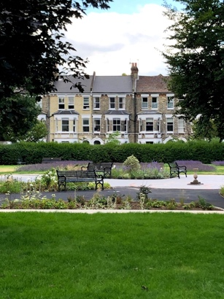
We now move into our newly created Fawcett Garden. This area has been completely redesigned, as part of our recent works and is filled with plants chosen for their sensory nature and the paths made to be wheelchair friendly. It has been named in honour of Millicent and Henry but I’d like to think that Henry, who was blind, would particularly appreciate the new planting. Other measures that we have introduced into the Park recently to improve accessibility is a metal ‘tapping’ edge to the grassed areas to that visually impaired people can find their way around the park. The gates into the Playground are both bright green, again so that visually impaired people can locate the gates easily. We have also improved the safety of the tennis courts and Muga by creating an alternative exit to allow options for escape in a dangerous situation.
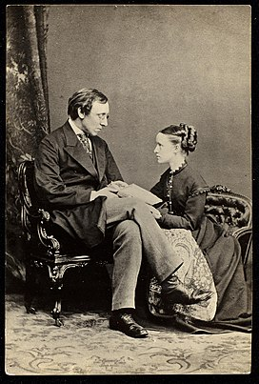
Henry, had been blinded in a shooting accident when he was 25, but he did not stop him living an extraordinary life. He was a Member of Parliament, campaigned for Women’s suffrage and was appointed Postmaster General besides being an eminent economist. As Postmaster General, he made it possible for poorer people to save, to have life insurance and was responsible for other innovations including parcel post, postal orders, and licensing changes to permit payphones and trunk lines. He is listed on the Reformers’ monument in Kensal Green. Henry, and Mark Beaufoy were both Liberal MPs, so I imagine Mark would have been there, at those lively discussions around the Fawcett’s dining room table, as the campaigns to improve people’s living conditions and to give women the vote, gained traction.

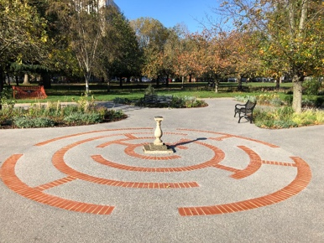
As we walk past the beautiful planting in which local children have recently been planting bulbs, we can see the brick labyrinth. Some of you might remember that it used to be set into the grass not far from its present position. It had bricks missing and it was a regular job of the Friends gardening groups to clear the grass to make it visible. I’m hoping that one day, someone will tell me what it’s history is. I’m told that there might be a clue in the Southwark Archives. It has now been completed and set centre stage with a sundial, given to us by the family of our first Chair, Alexander Macintosh, set in the middle.

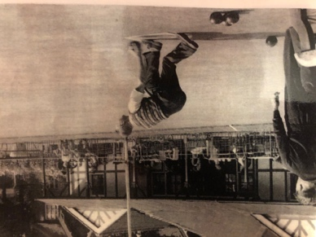
This area also holds our lavender field. This field was originally the site of two bowling greens at one stage, but one eventually, complete with tea pavilion. By the 1990s, although the green was in excellent condition, no bowlers could be found to use it, so it was decided that something had to be done. At about the same time, Vauxhall Motors, whose first factory was on the site of the Nine Elms Sainsburys, were celebrating their centenary and looking for a local project to sponsor to mark this. A now, unknown, person came up with the inspired idea of a lavender field. Vauxhall agreed to sponsor the field and it was planted in 2004 and thrived. The inscription on the Commemorative stone says “here’s your sweet lavender, sixteen sprigs a penny, that you’ll find, my ladies, will smell as sweet as any’ a lavender seller’s cry of about 1900.

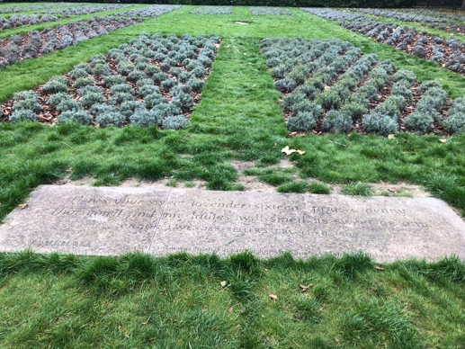
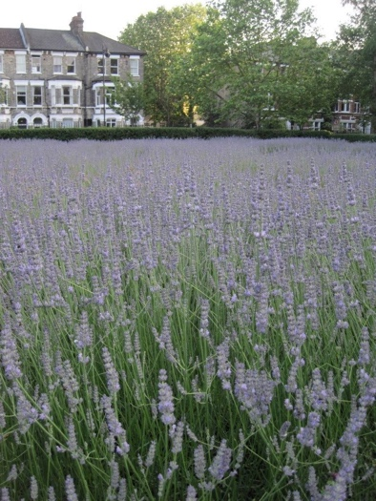

Another happy coincidence came about when a local resident, walking through the park when the flowers were being cut, was horrified to hear that they were to be composted. She had a connection with the Carshalton Lavender Field, where they distill their lavender flowers to produce oil. And so the Vauxhall Park lavender harvest was born. For many years, during the first weekend in September, literally hundreds of people come from all over London to help us cut the flowers. It is a magical event. The flowers are then loaded into our cars and transported down to Carshalton for distilling.

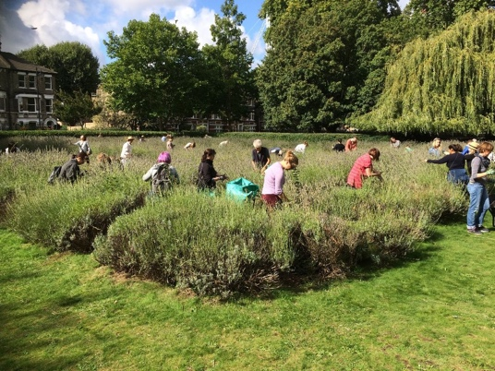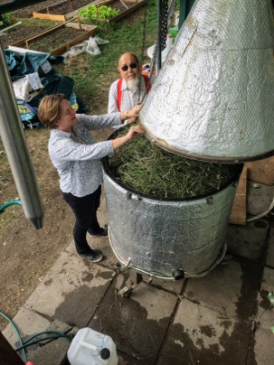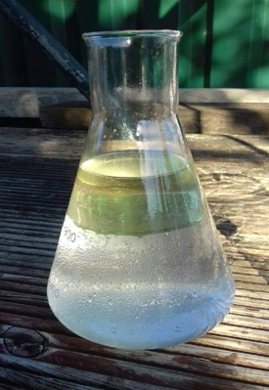
I can honestly say that this is one of my favourite park events of the year – sitting in the Carshalton lavender field, putting the world to rights while the smell of lavender distilling drifts over us. In the background of the photo of the Still being loaded up with lavender, is Laurie who lets us use this Still that he built. Remember those red braces… The oil, and lavender infused ironing water are sold locally in Vauxhall and all profits come back into the Park. The original lavender, which was the Grosso variety, came to the end of its life and has recently been replanted, and is still Grosso. It is too young to distill at the moment but we hope to recommence the harvest in 2022.

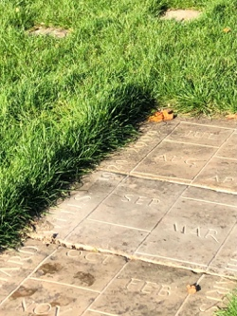
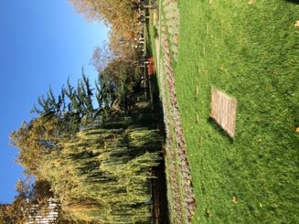
Set in the middle of the lavender field is our human sundial. This was given to the park by a local resident and is a wonderful example of science in action. After much deliberation, it was set to Greenwich Mean Time rather than British Summer Time – you stand on the current month and your shadow will tell you the time! During the improvement works, the FOVP paid for its restoration. I took many careful measurements of how it was set out but was thoroughly flummoxed by them when we came to reset it. Luckily, one of the chaps lifting the stones back into place came to the rescue: having not said very much during the heavy lifting, he looked at me and said ‘well, it’s triangulation, of course’ and then set about positioning the stones (thank goodness)

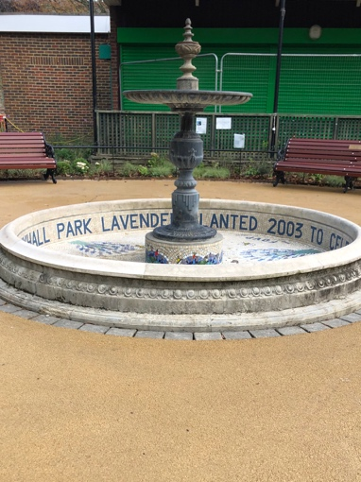
As we leave the lavender field and walk back towards the playground, past the green building, which we hope to transform under Phase two of our improvement works, I can see you looking at the beautiful new lavender mosaic in the fountain basin. We wanted to mark the contribution of the lavender field to the Park so, with the financial help of Lambeth, we designed the mosaic and it was created for us by the London School of Mosaics. We are extremely proud of it and hope that the fountain pump will be repaired and turned back on next Summer to complete the job. It depicts the Still, harvesters, Victorian lavender bottles, a lavender scythe and, if you look carefully, Laurie in his red braces. See if you can spot them

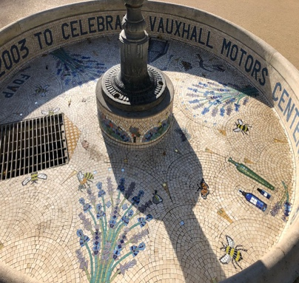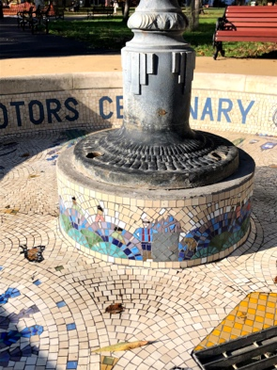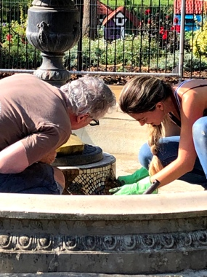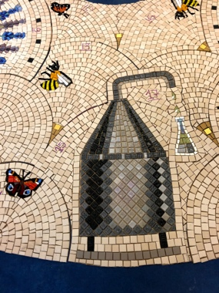

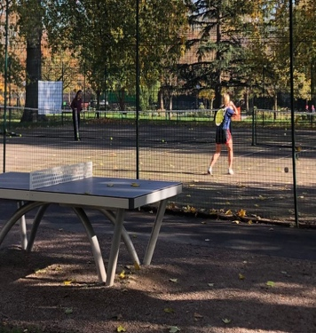
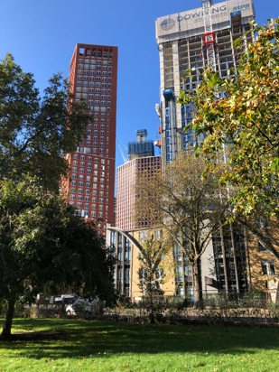
I have mentioned our recent improvement works a few times – this project has its origins in the many planning meetings and two planning inquiries that my colleague Helen Monger and I attended over recent years, as the plans for the tower blocks around the parks started coming out of Lambeth’s planning department. A very painful experience for us two. We now have approximately 5000 new people living alongside the park, who are very welcome and we hope will use the park, but the cumulative lack of investment in the park over the years needed addressing, if the Park was to cope with its new neighbours. Through our engagement with the planning process, we secured substantial planning gain monies, specifically for the Park and it is this money that has funded our improvements. The project has been six years in the making, has seen six project officers come and go and encountered soil contamination, lockdown, and vandalism but we are absolutely delighted with the result. Please come to the Park and see for yourself how it has been transformed. But the Park is just a better version of itself somewhere you can come to withdraw from the increasing urbanisation around it, join in with the community gardening (still allowed under lockdown), play some tennis, ping pong, or basketball (out of lockdown though) or walk your dog (but please don’t cycle). We are always delighted to see people using the park for their mental, as well as their physical health, especially during the recent lockdowns. I am especially pleased by the visits to the Park by the Lambeth Autism Group and have spotted the occasional shaman group in the Park.

Now, our footsteps are leading us back to where we started and I can see Domingo, the manager of Parco Cafe, which will be open for takeaways during this lockdown, on the terrace. Perhaps you would like to enjoy a hot drink and I dare you to resist a cake, or an ice cream, depending on which season you decided we were walking in. I can recommend the lasagne. And as dusk descends on the Park, you might catch a glimpse of the shadow of Charlie Chaplin, who grew up in Kennington and, we’re told, played in Vauxhall Park as a child when the Park was still relatively new, with the grandmother of a local resident.
Before we say goodbye, I’d like to give a plug to Lambeth Libraries and the Tate South Lambeth Library in particular. Please do join, if your local library has a friends group – they do amazing things.

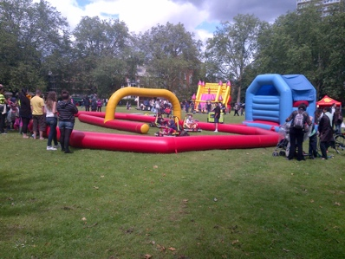
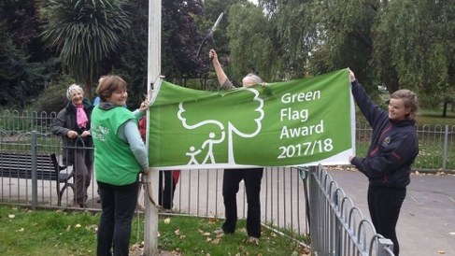
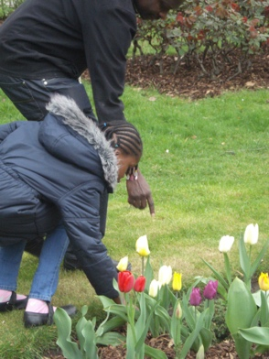
I hope you will join the FOVP (Image of Green Flag, Summer Fair & Easter Egg Hunt) as the park sets out on the next chapter of its history. We started in 1999 and are a registered Charity. We have a committee that organises events in the Park and represents park users in conversations with Lambeth Council. All of our events and news are on our Website, Twitter, Instagram and Facebook feeds, do follow us. We also find offers of sponsorship for the Park’s benches and I’m pleased that the very dodgy looking selection of wooden benches that were in the Park, have been replaced by the very smart metal ones, which we hope are vandal proof! We still have a few spots to fill but are limiting the total number so contact us soon if you’re interested in helping us to complete the job. We are extremely proud that the Park has just retained its Green Flag and are planning a very special official opening of the Park next summer. Perhaps not with royalty in attendance this time, but an event that, I hope, will go down in Vauxhall Park’s rich history.

I am often to be found in the Park with my dog but if you don’t find me there, sit on the bench dedicated to Edgar Wilson by the fountain, listen to the children playing in the playground, look at the lavender mosaic and the model village beyond and see if you can smell the lavender wafting over the Park, and you will have met me. I hope you might join me in person on my next actual guided historical walk around the park, I am off to follow up on those two new strands of research. Thank you so much for joining me this evening

