FRIENDS OF VAUXHALL PARK NEWSLETTER No. 37

Registered Charity 1166894 www.vauxhallpark.org.uk

A Celebration!
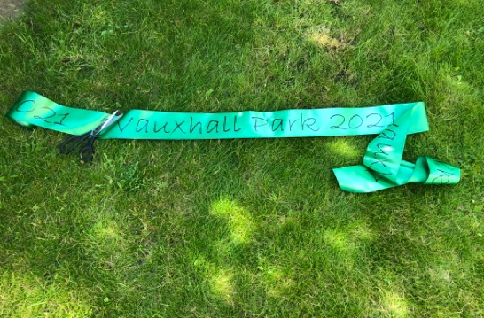
On 11 September between 2-5pm we will be celebrating the recent improvement works in the Park with The Vauxhall Park Celebration an afternoon of free fun for local children, paid for by FOVP with generous support from Winkworth Kennington. To start the event, at 1.45pm, we are inviting lots (and lots) of local children to help us to cut an 120m long ribbon stretching across the grassy area! We are delighted that Florence Eshalomi, MP for Vauxhall, will be compèring the ribbon cutting for us to put the children in the spotlight. There will be a large arts & crafts area, strolling magician, balloon modelling workshop, free tennis coaching (by G tennis) a fun dog show (by The Hound Hut), fairground rides, food & drink, Vauxhall Lavender activities, face painting, Bureau of Silly Ideas and local musicians. Please do come to join in our fun.
Children who would like to take part in the ribbon cutting must be accompanied by an adult – please email friends@vauxhallpark.org.uk to be part of this historic event. We are also looking for people to help on the day, please email as above.
Would you like to promote your business to our community? We would love to promote you as part of our event. Pitches (non-food only) are available for a modest fee. Please email for further information.
… and a Harvest
On 4 and 5 September, from, 10.30am we will be harvesting the lavender flowers. Please do come to join us and bring your own gloves, and secateurs if possible. You are welcome to take away some lavender (it’s brilliant for deterring the pesky clothes moths), the rest of it will be used by our very own lovely lavender lady for the lavender activities at our Celebration
Vauxhall Park Masterplan and future
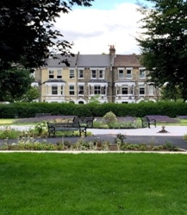
We are delighted that the improvements to Vauxhall Park are finally (just about) finished. There is still quite a long list of ‘snagging’ items which we are continuing to pursue with the Lambeth including the weak spot in the park railings, lack of drinking water, tree works etc. We were very pleased that the missing noticeboard by the MUGA entrance has now been installed. The second phase of the Masterplan which addresses the future of the Green Building has been put on hold for the time being whilst sufficient funds are allocated to the project by Lambeth. We thank our Councillor Claire Holland for taking the time to visit the park recently and taking interest in it. We have discussed ways to involve the wider community in the Park and hope to do this in future, She thanked the volunteers for all of their hard work and was verty impressed by what we have achieved for such a small group

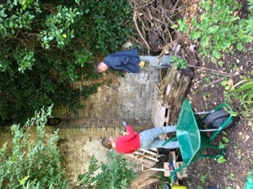
Bees Please!

Better biodiversity has been an ambition of ours for some time so we were very pleased to be able to start the construction of a Conservation Area in a quiet part of the Park. Insect ‘hotels’ have been installed and a bog pond created. We are hoping to create an area of wildlife friendly planting but are waiting until we can stop footballs flying over the fence from the playground!

Awards Season
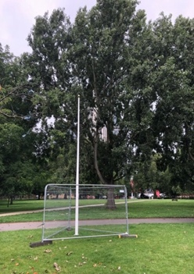
A judge from London in Bloom visited the Park over the summer and we are looking forward to hearing the results. We think she was quite impressed and are hoping to improve on the Silver Gilt Award given to Vauxhall Park last year.

The Park has again been entered for the Green Flag Award so we were pleased to see that a new flagpole has replaced the old one that was rotten. The evaluation has been done by a unscheduled visit by the judges. We are crossing our fingers that we will soon be flying a 2021/22 Green Flag. Watch this space!

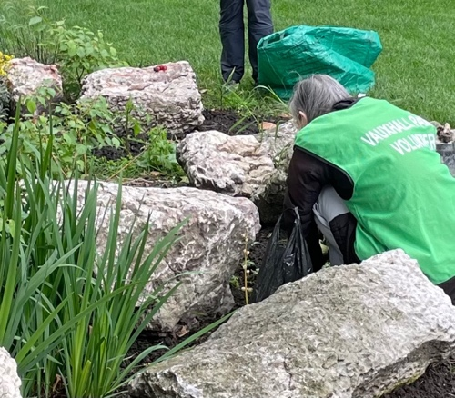
Volunteer Gardening Groups

Regular volunteer gardening groups have been working hard over the past few months and the park is showing the results of all of their hard work. We now have a separate group for children and their families and were delighted by the enthusiasm of local families and their children during the planting of the spring bulbs given to us by Idverde. If you would like to hear about future gardening groups and to be part of the WhatsApp groups please email friends@vauxhallpark.org.uk.

Membership Secretary Vacancy
We are very sad that Anne Rogers, our wonderfully efficient Membership Secretary, is moving away from the area. We would like to thank her for all her work and support of the FOVPs work. Would you be interested in replacing her? The role involves a couple of hours a month with maybe a bit more around the AGM. It’s a great way to become involved with the FOVP and no experience is required. Please email us for more information (friends@vauxhallpark.org.uk).

FOVP AGM 13 November
Venue to be confirmed
This Photo by Unknown Author is licensed under CC BY-NC
This Photo by Unknown Author is licensed under CC BY-SA

