FRIENDS OF VAUXHALL PARK NEWSLETTER No. 38

Registered Charity 1166894 www.vauxhallpark.org.uk

Celebration 2021 .. didn’t we have fun!
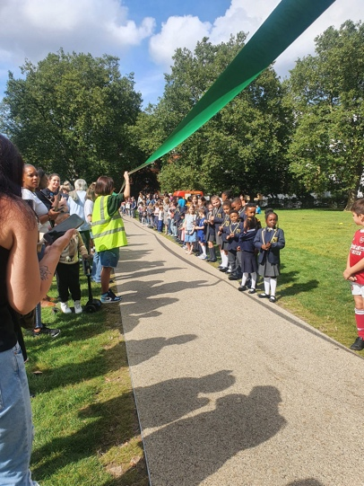
Thank you to everyone who helped celebrate the completion of Phase 1 of the improvement works. Florence Eshalomi MP introduced the 300 children of Vauxhall who officially reopened the park by cutting our bespoke 120m long piece of ribbon. An afternoon of fun was had by all afterwards with bouncy castles, whirling teacups, music, food and games. We are grateful to the many supporters of the afternoon: Winkworth Kennington for producing the event publicity and sponsoring the engraving of the children’s scissors, DJ Obi Smalls for getting us dancing, G Tennis for providing tennis coaching, Hound Hut for overseeing the dog show, the Oval Montessori Nursery for providing arts & crafts and the Vauxhall Lavender Lady for providing a very special lavender stall using Vauxhall Park’s own lavender. Here’s to the next 130 years of Vauxhall Park!

Volunteer Gardening
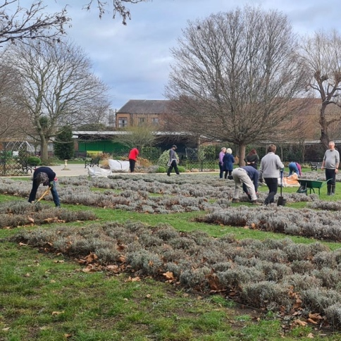
Our wonderful volunteer gardeners have been hard at work during the winter months to keep the Park in good shape. They have planted bulbs, cleared lots (and lots) of leaves, weeded and pruned the lavender field and enjoyed hot drinks and resisted cakes at Parco after each session. Please email friends@vauxhallpark.org.uk if you would like to be added to the WhatsApp group where details of working parties are posted. We hope their work will lay the foundations for the Park retaining its Green Flag and London in Bloom Gold Award.
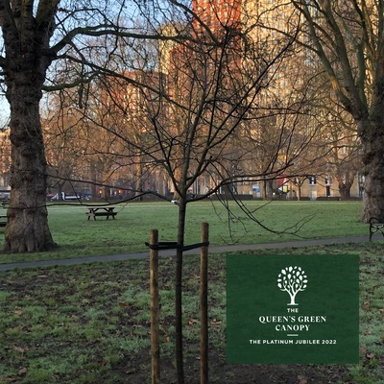

Queen’s Green Canopy Plant a tree for the Jubilee
We are delighted that a new quince tree, sponsored by a local family and planted in the community orchard is now part of the Queen’s Green Canopy. This is an initiative to encourage local communities to plant trees during Her Majesty’s Platinum Jubilee year. Please visit the Queen’s Green Canopy website www.queensgreencanopy.org to see our tree on their map and learn more.

Improvement Works
Following the consultation that was carried out last summer, we are delighted that a budget has been agreed and a steering committee set up to address the future of the green building near to the playground. Our hope is that the new Pavilion will provide toilets for park users, possibly a small kiosk selling light refreshments, facilities for gardening groups and a dedicated play space for under 5s away from the activity of the main playground. We will post updates on park noticeboards and our social media channels as the plans come forward.
Meanwhile the snagging list from Phase I is yet to be completed. We are pleased that the additional trees promised have been planted but continue to press the Council on a number of other issues including replacing the vandalised playground equipment, rectifying the fencing to stop dog fouling in planted areas, completing the tennis courts …

Biodiversity in Lambeth
Lambeth Council have recently set up a Biodiversity Forum which seeks to implement new biodiversity rules including the requirement for new developments to demonstrate Biodiversity Net Gain. We are pleased that our new conservation area will contribute to Lambeth’s aspirations of Lambeth and the work of the Forum. Interested in helping improve the biodiversity of Vauxhall Park and the local area – join our gardening groups!

Council Ward changes
Under the changes to Lambeth Council ward boundaries that will be adopted this year, the Park will move from Oval Ward into the newly created Vauxhall Ward. We look forward to working with the Park’s future Councillors and thank the Oval Ward Councillors for their support in the past. If your house will also be moving into Vauxhall Ward, please could you ask the Councillors asking for your vote what they will do for this important local amenity?

FOVP News
We are very grateful to Sarah Chambers who has taken over as Membership Secretary. We welcome new members; you can join up online (www.vauxhallpark.org.uk/join-us) or pick up a membership form from Parco.

We have a vacancy for a Trustee to join the committee to help guide the park through the next phase of its history. Please contact us if you are interested (friends@vauxhallpark.org.uk)

Get Social with us!

This Photo by Unknown Author is licensed under CC BY-NC
This Photo by Unknown Author is licensed under CC BY-SA

