FRIENDS OF VAUXHALL PARK NEWSLETTER No. 39

Registered Charity 1166894
www.vauxhallpark.org.uk

A (Late) Summer Fair

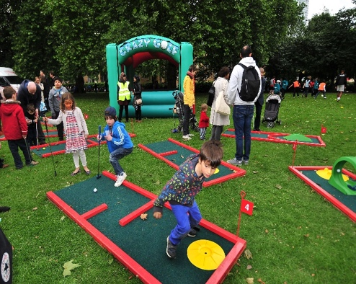
We are delighted to announce that we will be holding a Late Summer Fair on Sunday 10th September. There will be lots of fun to be had for everyone and we hope to finish the event with a family-friendly evening of live music and bring a picnic.

We would love to hear from local businesses who would like to promote themselves by taking a stall (for a modest fee). Please contact us friends@vauxhallpark.org.uk.

Volunteer Gardening and Awards

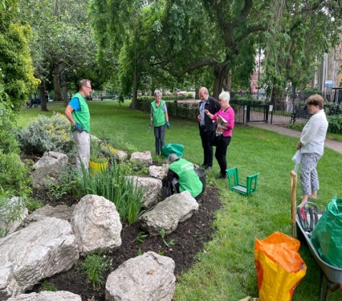
Our wonderful volunteer gardeners have been hard at work during the winter months to keep the Park in good shape. They have planted bulbs, cleared lots (and lots) of leaves, weeded and pruned the lavender field and enjoyed hot drinks and resisted cakes at Parco after each session. Please email us if you would like to be added to the WhatsApp group where details of working parties are posted. We hope their work will lay the foundations for the Park retaining its Green Flag and London in Bloom Gold Award. This year Vauxhall Park will be entered for the Green Flag’s Heritage category. We have recently been joined by a group of very enthusiastic children from St Stephen’s Primary School. They have shown great interest in the park, helped us with various jobs and used the park to back up their school work.

Consultation on Public Spaces Protection Order for Dogs

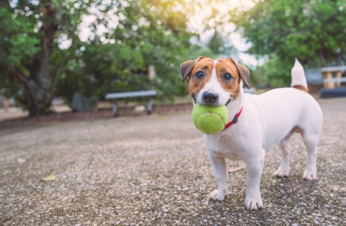
Lambeth Council are consulting on proposals to bring in a new Dog Control Public Spaces Protection Order. They want to hear from as many people as possible Lambeth.gov.uk/consultations/have-your-say-dog-control-lambeth. You should be aware that they are proposing that dogs can only be off the lead in the dog area in Vauxhall Park and Kennington Park. Let them know what you think! The consultation closes on 26 March 2023.

The Green Building and Phase 1 (still on the Council’s to do list…)
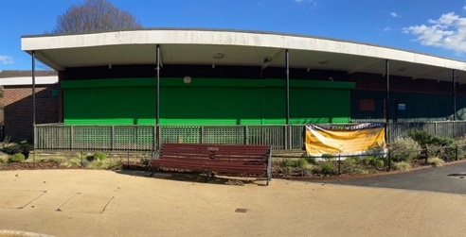
A planning application has been submitted by Lambeth for a new, smaller, more sustainable building to replace the current building which is beyond economic repair and too big for current uses. The FOVP paid for a consultation about the plans and the results were submitted to the Council. This new building will provide better facilities for the Vauxhall Park gardener, secure storage for volunteer gardening group’s tools, two toilets (both accessible with one for playground users and the other for general park visitors) and a small kiosk serving tea/coffee/ice creams/light snacks. The kiosk will allow for toilet provision; the lease holder will be required to lock/unlock and clean then. The team at Parco Café will be offered the lease of the kiosk which will serve both playground users and tempt those passing through the park to stay local rather than use the ‘chains’ at Vauxhall. We also hope to redesign the play area at the back of the building to create a play space specifically for those who find the main playground overwhelming.

Biodiversity in the Park
We are still hopeful that we will be able to welcome even more wildlife into Vauxhall Park when the conservation area is completed. Unfortunately, the long promised bike racks in the playground (to protect the planting from flying footballs, as well as to provide secure parking for playground visitors’ bikes) were put in the wrong place so the planting up of the area will have to wait until the Parks Improvement Team can be persuaded to come back to put right the work done. Meanwhile, the insect ‘hotels’, bird and bat boxes ensure that wildlife is given a home in Vauxhall Park.

Fanny Wilkinson
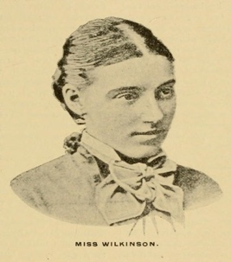
The designer of our park was the subject of an article The Remarkable Fanny Rollo Wilkinson in the January issue of Country Life Magazine. Her extraordinary contribution to the availability of open spaces for Londoners has long been underestimated. With her recently installed Blue Plaque (on 239/241 Shaftesbury Avenue), appreciation of her work and life is receiving the attention it deserves.

FOVP News
Our AGM will be held on Saturday 10 June 2023. We welcome new members; you can join up online (www.vauxhallpark.org.uk/join-us) or pick up a membership form from Parco.

We welcome new Trustees to join the committee to help guide the park through the next phase of its history. Please contact us if you are interested (friends@vauxhallpark.org.uk)

Get Social with us!

This Photo by Unknown Author is licensed under CC BY-SA
This Photo by Unknown Author is licensed under CC BY-NC

