FRIENDS OF VAUXHALL PARK NEWSLETTER No. 40

Registered Charity 1166894
www.vauxhallpark.org.uk

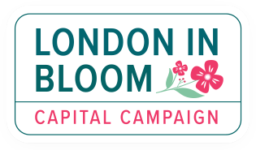
We are delighted that Vauxhall Park has not only retained its Green Flag, but also its London in Bloom Gold Award

Conservation Area
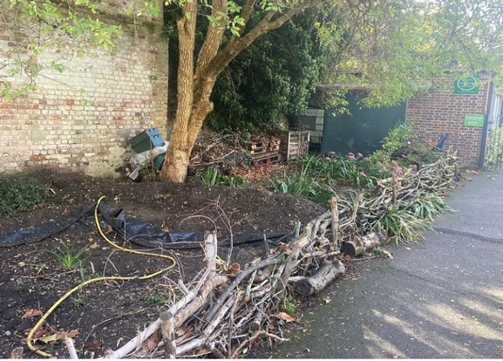
For this year’s award judging season, we were proud to show off the Conservation Area. Now that the footballs are being kept out by the bike racks, it has come on leaps and bounds through the work of our volunteers. We are planning to plant it up this autumn with pollinator friendly plants.

We have a beautiful ‘natural’ fence made of out fallen branches and twigs from around the park. This will guide onlookers to where they can safely stand to watch the wildlife without damaging this special environment. We hope that the bog pond, which we have reinstated, will encourage some amphibians to visit.

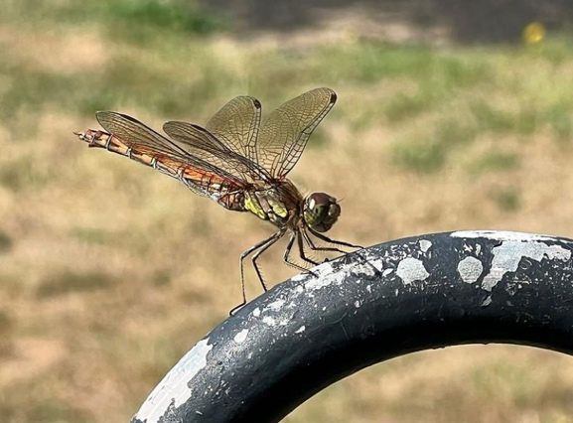
Visitors to the park that we have spotted included a dragonfly, a wasp spider (agriope bruennichi) and some crickets. Please do let us know if you spot any unusual wildlife in the park!

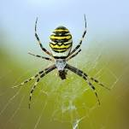

Lavender Harvest
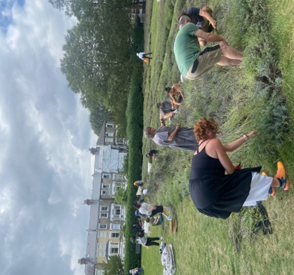
This year’s lavender harvest attracted volunteers from further afield than ever before after BBC Radio London’s Riz Lateef Breakfast show included an interview about the event. More than 150 people came to help over the harvest weekend in early September. Sadly we were not able to distil the oil from the flowers this year but the profits from sales of oil from previous harvests will be used to replace lavender plants that have died.

For many years, Ruth Morgan has masterminded the distilling and selling of the lavender oil. It was her vision that enabled us to take the lavender down to the Carshalton Lavender Field and her talent in creating the stylish blue bottles with specially designed labels that helped to ensure that the lavender oil sales provided a healthy contribution to lavender inspired projects in the Park. She helped to design the lavender mosaic in the fountain and provided a hugely popular lavender themed activity for our Celebration event in 2021. We are very sorry that she has had to step back from this role and would like to thank her for her wisdom and enthusiasm over the years. We hope to resume distilling the oil from the lavender flowers in 2024, led by a new team.

Volunteer Gardening
Following signs up by lavender harvesters, we now have over 100 people in the Volunteer Gardeners WhatsApp group. They meet regularly to help maintain the park, especially now that Lambeth Landscape’s gardener is only in the park for two days a week now (rather than five). The group is now gearing up to support Lambeth Landscapes with the huge task of collecting fallen leaves – could you help us? Please email us to be added on to the WhatsApp group (friends@vauxhallpark.org.uk). We were pleased to thank the gardeners with a party at Parco, attended by our MP Florence Eshalomi and local Councillors.

The Green Building and Phase 1 (still on the Council’s to do list…)
No news on the Green Building and no progress on the snagging list (from 2020..)

FOVP Trustees and some thank yous
We would like to thank Lyn Woodcraft our Treasurer who has recently stepped down. We will miss her reliable efficiency and cheerful approach to all things financial (except, that is, to the increasing burden caused by our bank’s procedures). We welcome Tom Anstey as a new Trustee and Treasurer. We would also like to thank Mandy Knight, FOVP Secretary, is also leaving the committee. She has been a steadfast backbone for the FOVP, organising and recording our meeting as well as dealing with the regular enquiries that come in. We hope to continue seeing her at our gardening groups. If you would like to join the committee to help guide the park through the next phase of its history. Please contact us (friends@vauxhallpark.org.uk).

Get Social with us!
This Photo by Unknown Author is licensed under CC BY-NC
This Photo by Unknown Author is licensed under CC BY-SA

