
FRIENDS OF VAUXHALL PARK NEWSLETTER No. 41
Registered Charity 1166894
www.vauxhallpark.org.uk

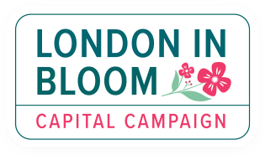

We are delighted that, for 2026, Vauxhall Park has retained its Green Flag, the London in Bloom Gold Award and continues to be recognised as a Green Heritage Site

Lavender Harvest

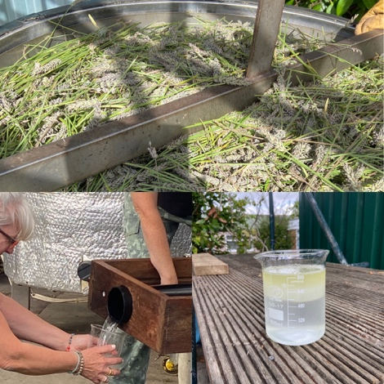
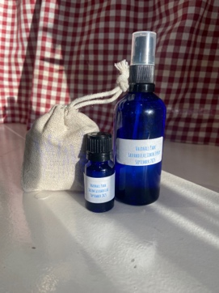
After being delayed by the rain, a harvest of the lavender flowers took place rather later in the autumn than we would have liked. We are grateful to the many people who came along to join in the fun over the harvesting weekend, and those who came down to Carshalton lavender field where the flowers were distilled into oil and hydrosol (or lavender water). Both these products are on sale at Parco Café, alongside bags of dried lavender – a perfect low carbon present!

Volunteer Gardening
With the extensive savings having to be made by Lambeth Council, which has impacted the Parks maintenance budget, the role of the volunteer gardening group has become even more important. Lambeth Landscapes will continue to mow the grass, clear litter, maintain trees and clear leaves. The maintenance of the ornamental planting is now looked after by our volunteers who meet most Saturdays. Why not come along to meet your neighbours, learn a skill and get a green workout?! Please email us (friends@vauxhallpark.org.uk) to be added to the WhatsApp group where dates are posted. One of our regular volunteers has gone on to complete an RHS course and another says ‘I really look forward to meeting up with the group, particularly enjoying the social side of the of making a difference to the park. I feel real pride in my contribution to the standard of the park’s upkeep when, otherwise, it wouldn’t look so good for park usersl’. The groups always finish with a sit down at Parco where gardeners are rewarded with a hot, or cold, drink.

The Pavilion and Phase 1 (still on the Council’s to do list…)
The Bad News …Still no news on when the Pavilion will be finished (and most importantly the toilets opened) but an operator for the kiosk has been chosen and we are hopeful that they may be open in time for the summer.
The Good News… Using donations given to the FOVP, the bed in front of The Pavilion has been planted up which will give us a year-round display to enjoy. We are grateful to Tessa who designed the planting and made sure we put the plants in the right place!

Defibrillator

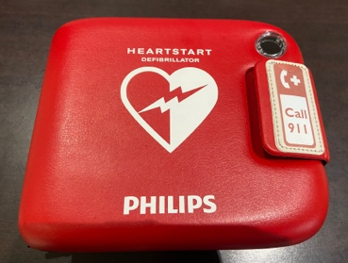
The Oval Montessori have generously donated a defibrillator to the Park. We are also grateful to Parco Café where the defibrillator is located. We hope it is never needed but very glad it is available.

We were saddened by the fire at the Oval Montessori Nursery School and glad that the restoration project finally got underway after nearly six months. The staff and children of the school are great supporters of the park, we wish them well in their renovated building

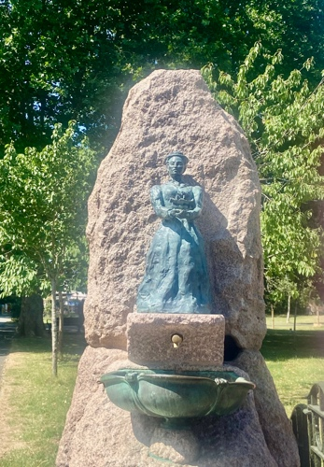
Fanny Wilkson Statue

We were very pleased to join the Friends of Coronation Gardens, Wandsworth Council, The Heritage of London Trust and the Metropolitan Public Gardens Association at the unveiling of a statue of Fanny Wilkinson in Wandsworth’s Coronation Gardens. Like Vauxhall Park, Coronation Gardens was designed by this remarkable lady who was the first professional female landscape designer. Further information about Fanny and her involvement with Vauxhall Park can be found on our website. The statue joins the blue plaque to Fanny in recognising the enormous contribution that she made to Londoners’ lives.

The Fountain
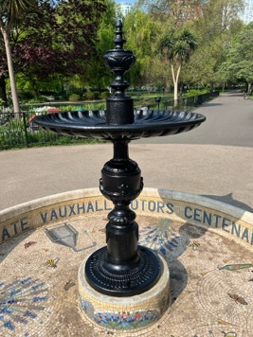
During the brief bit of the summer of 2025 when it wasn’t raining (or baking hot), the FOVP used donations given by members and supporters to repaint the fountain. We hope you agree that it sets off the wonderful lavender mosaic beautifully and will bring joy to park visitors for many years to come (and not just the pigeons who love the water).

Get Social with us!




This Photo by Unknown Author is licensed under CC BY-NC
This Photo by Unknown Author is licensed under CC BY-SA

